The IIE Varsity College

CLDV6211

Cloud Development A

ST10088532

POE Part 1&2

Aobakwe Kegoriloe

Due Date: 07 April 2025

ERD diagram

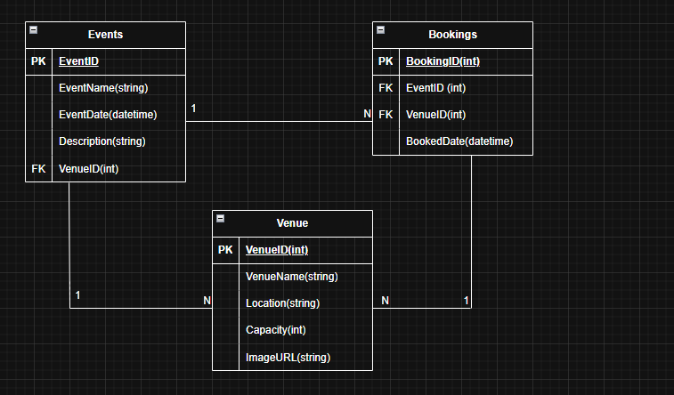

Screenshots of Web App

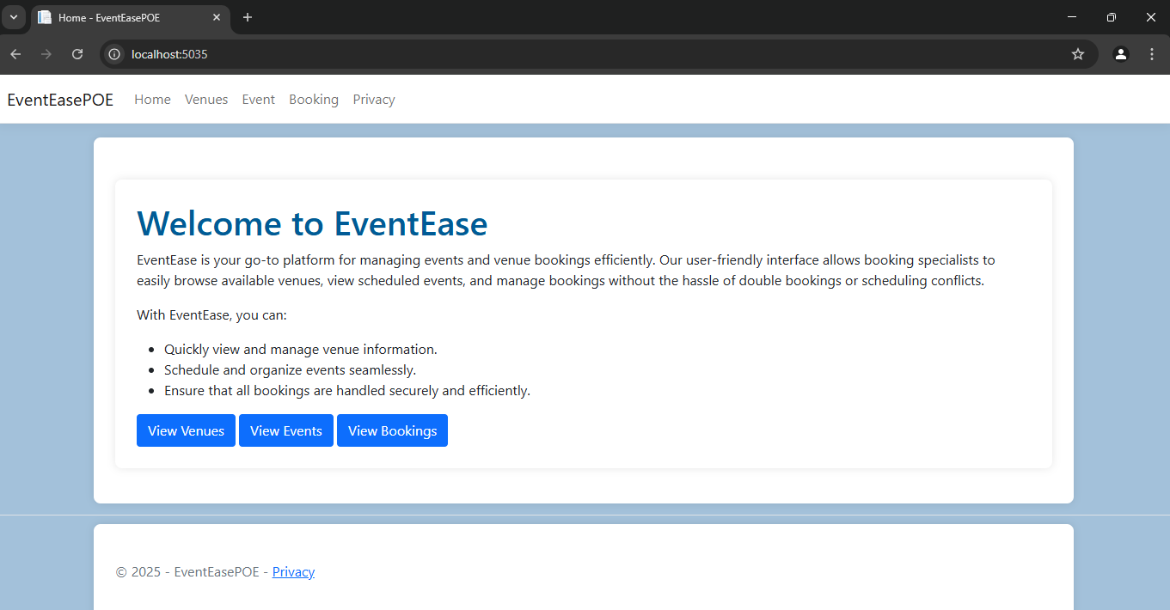

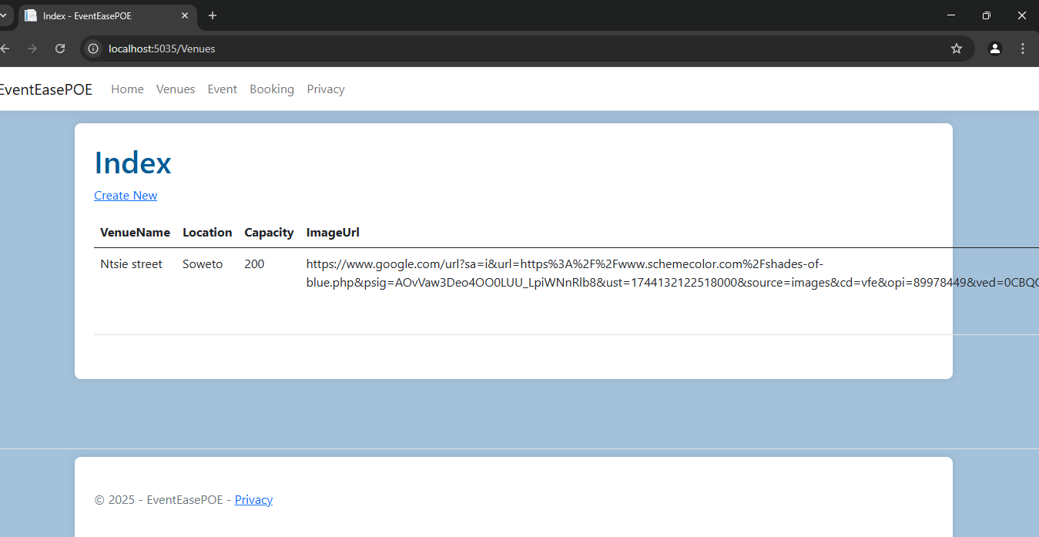

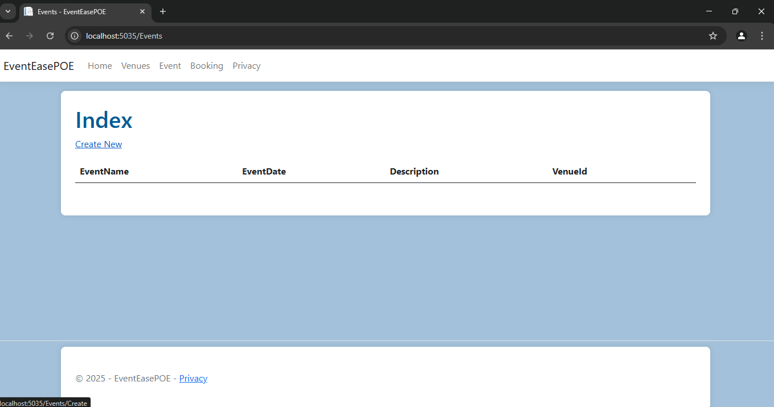

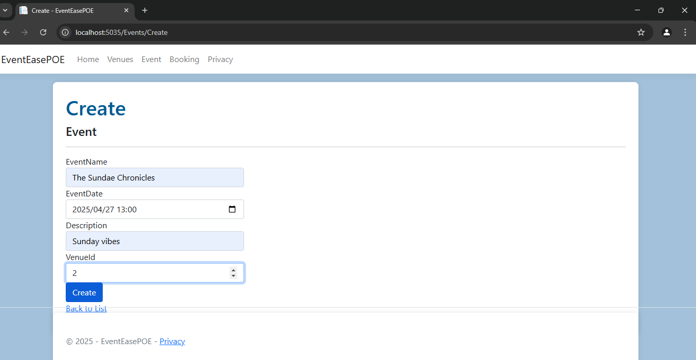

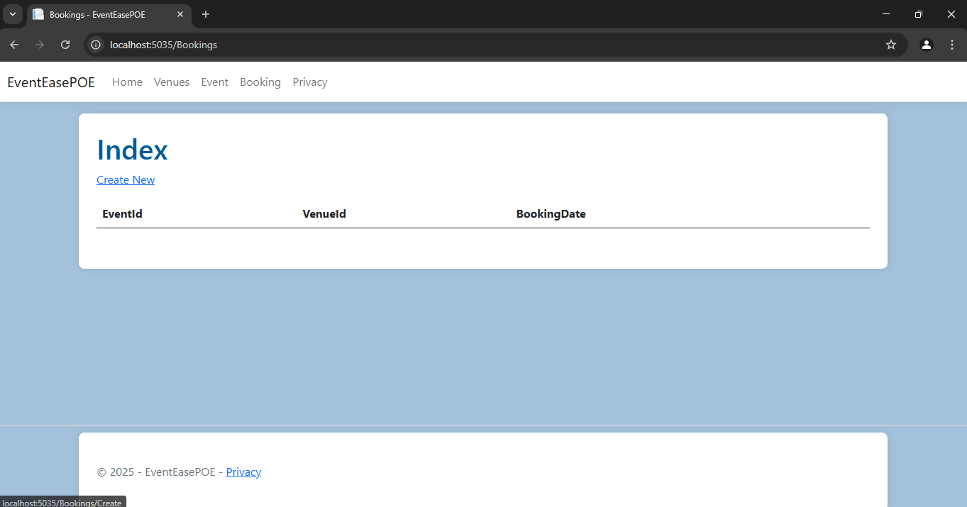

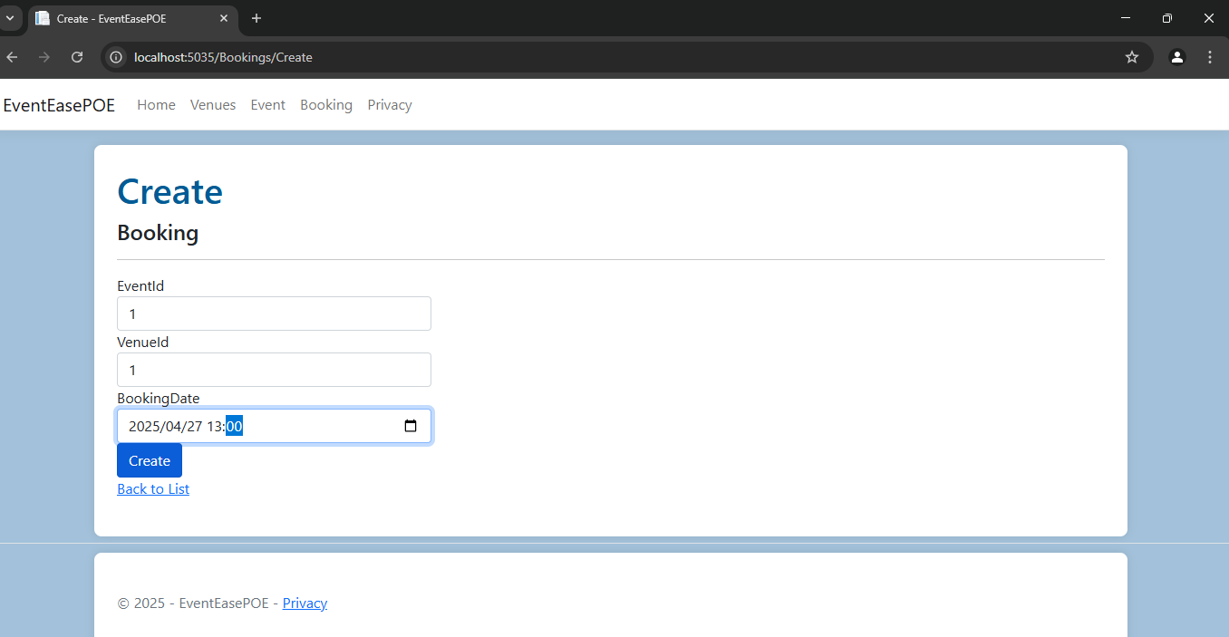

Visual Studio Code

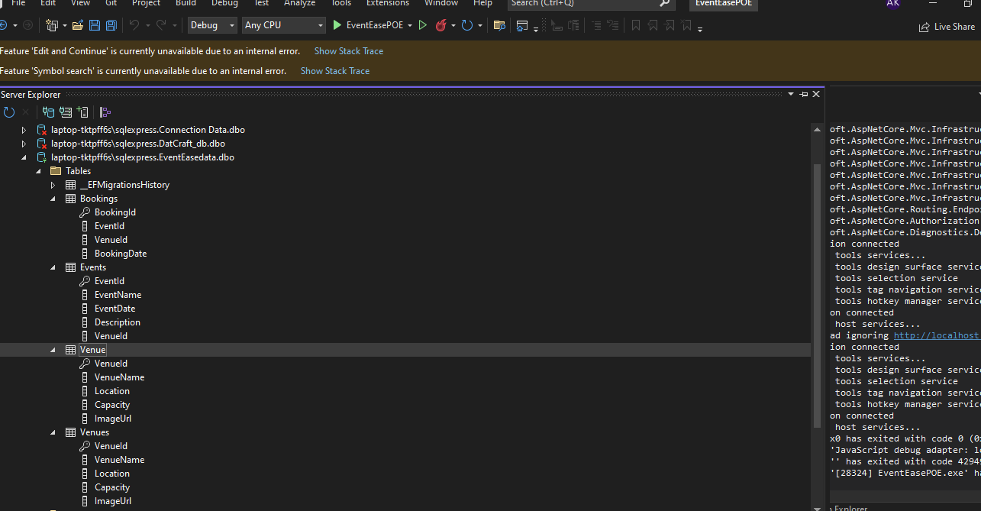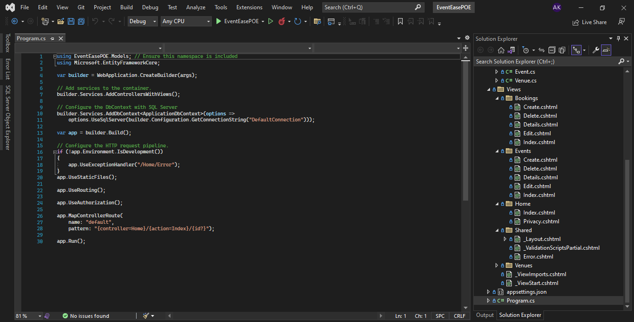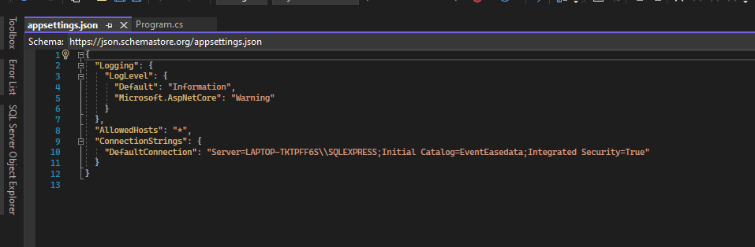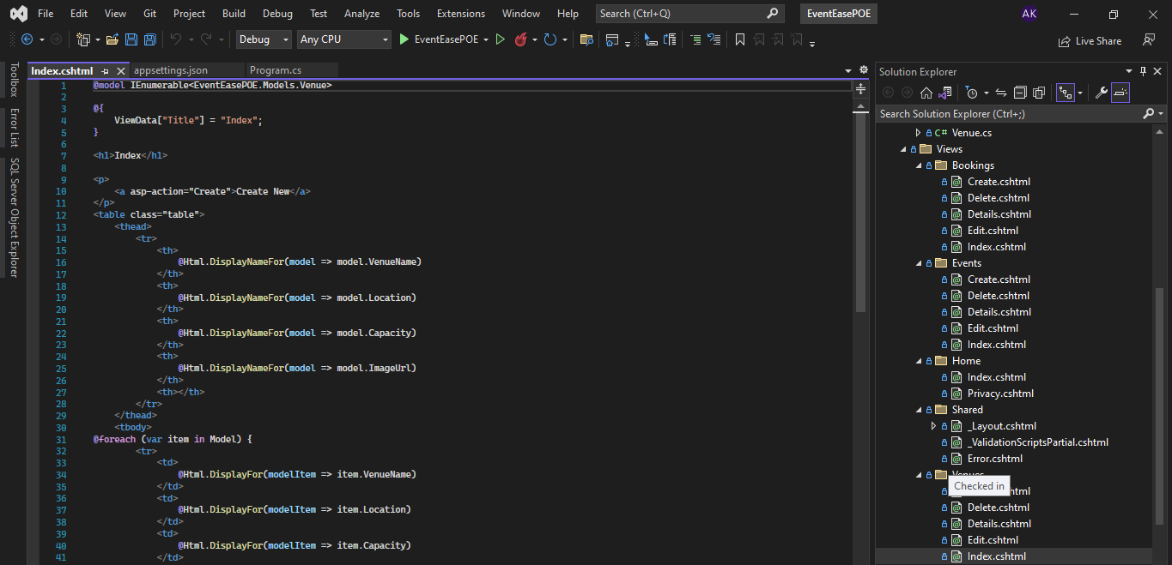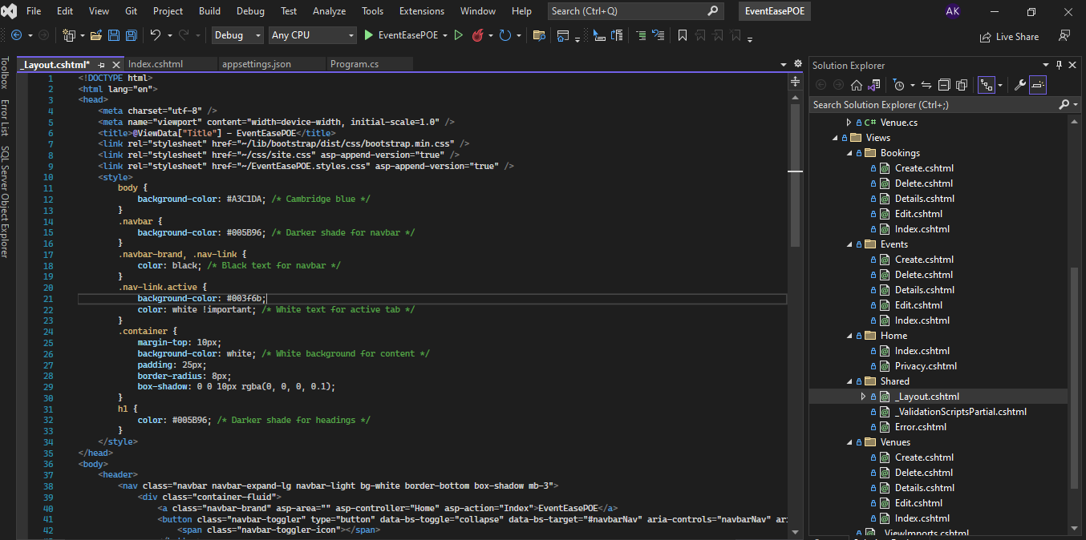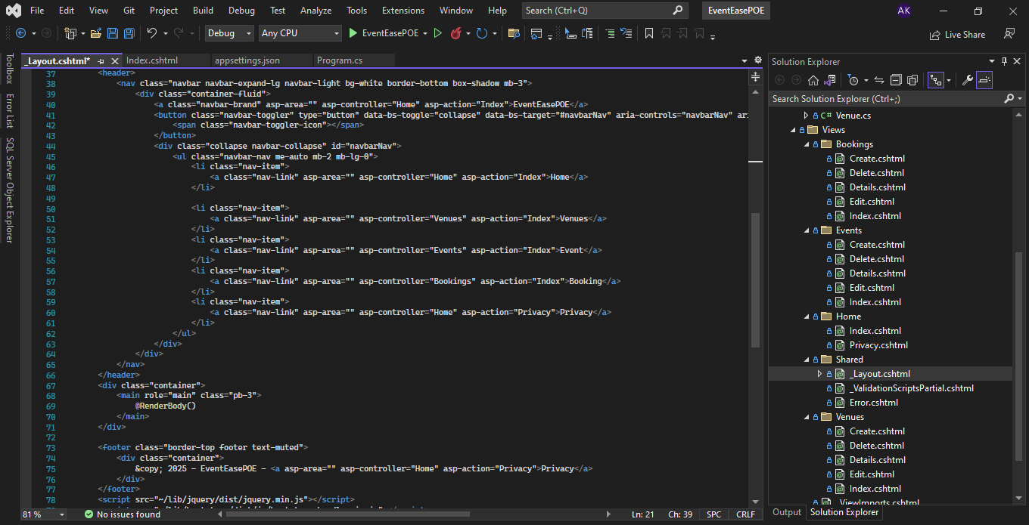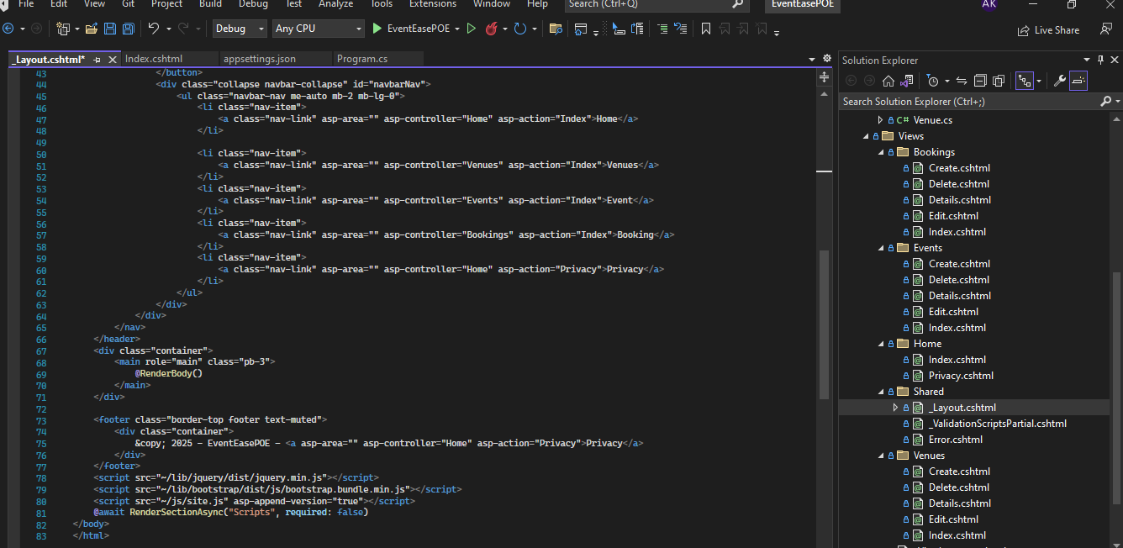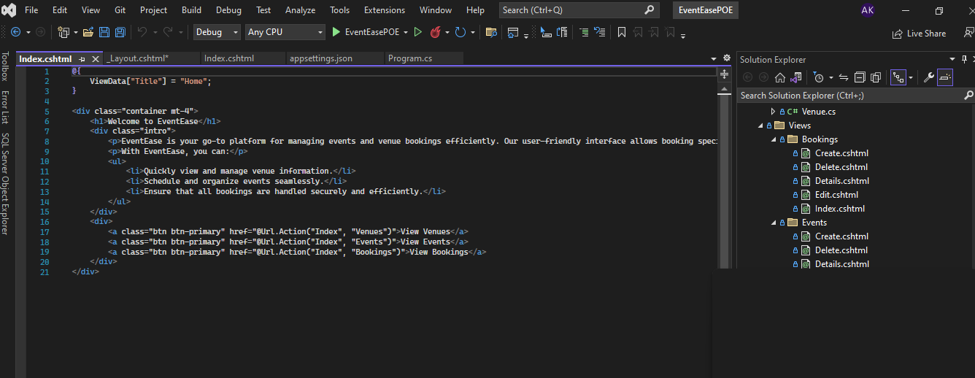

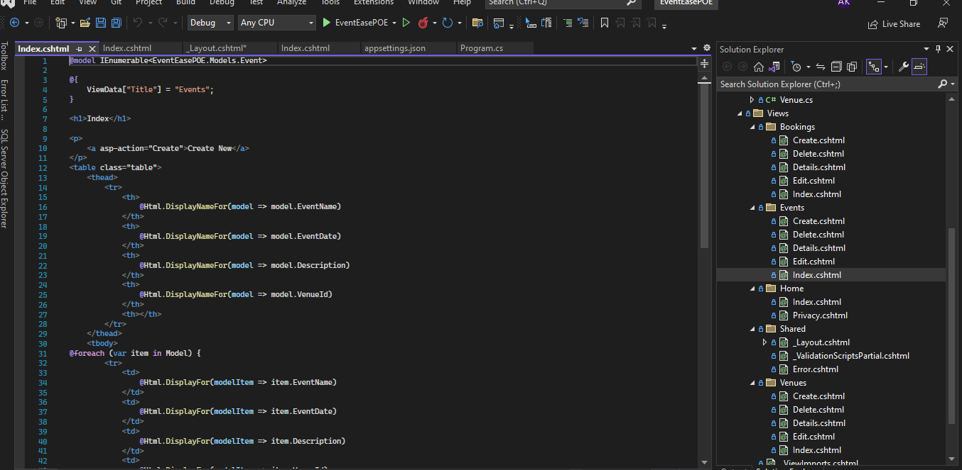

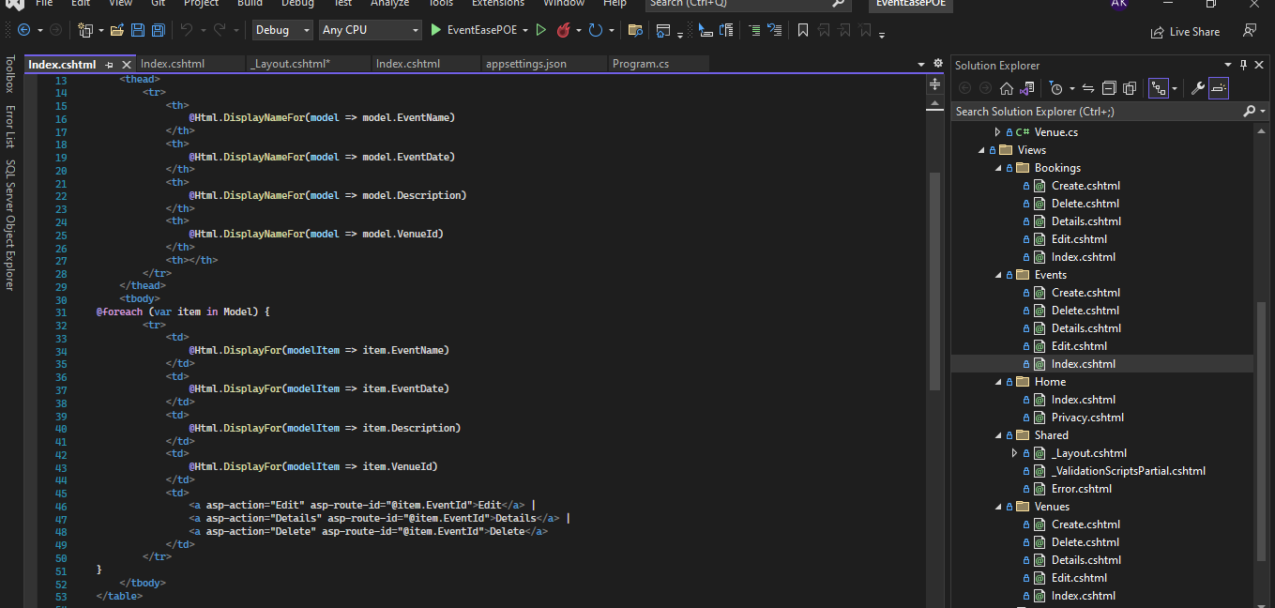

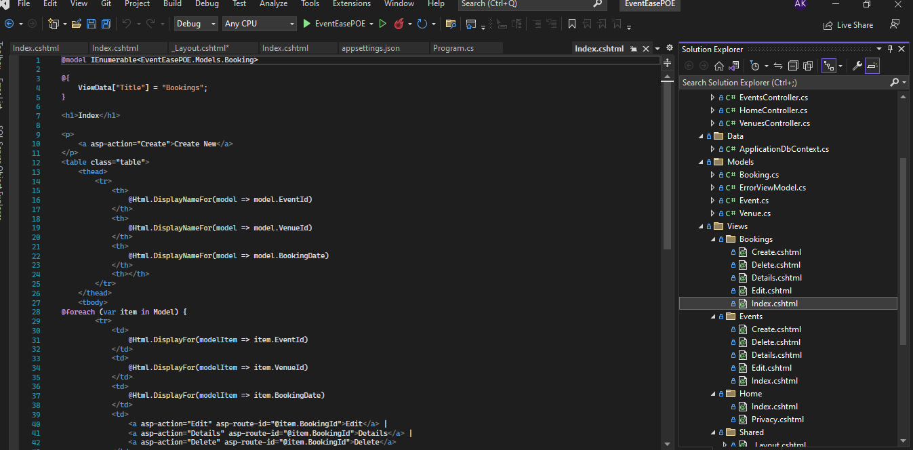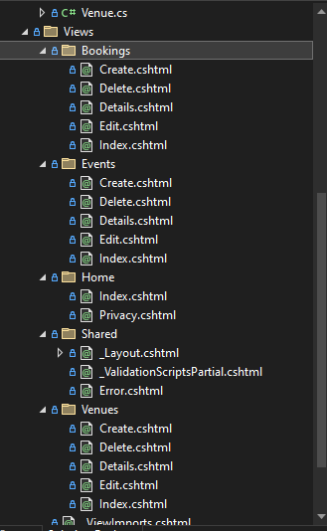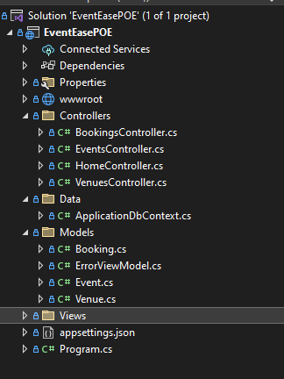

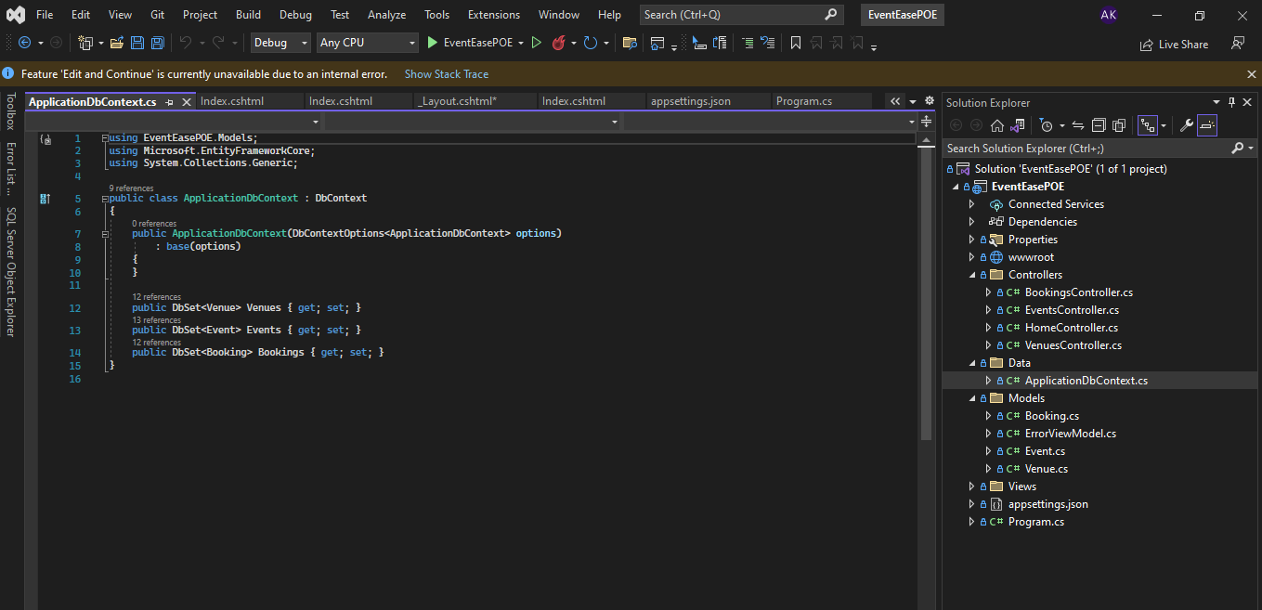

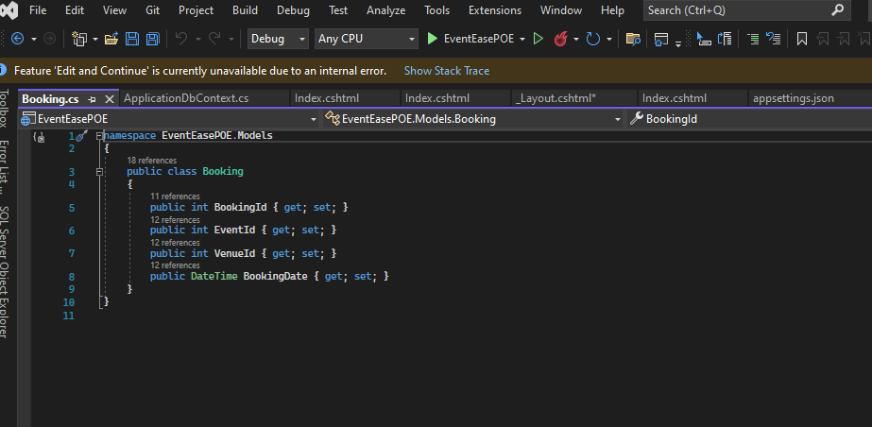

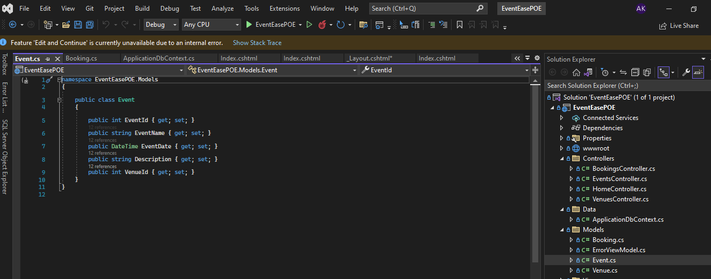

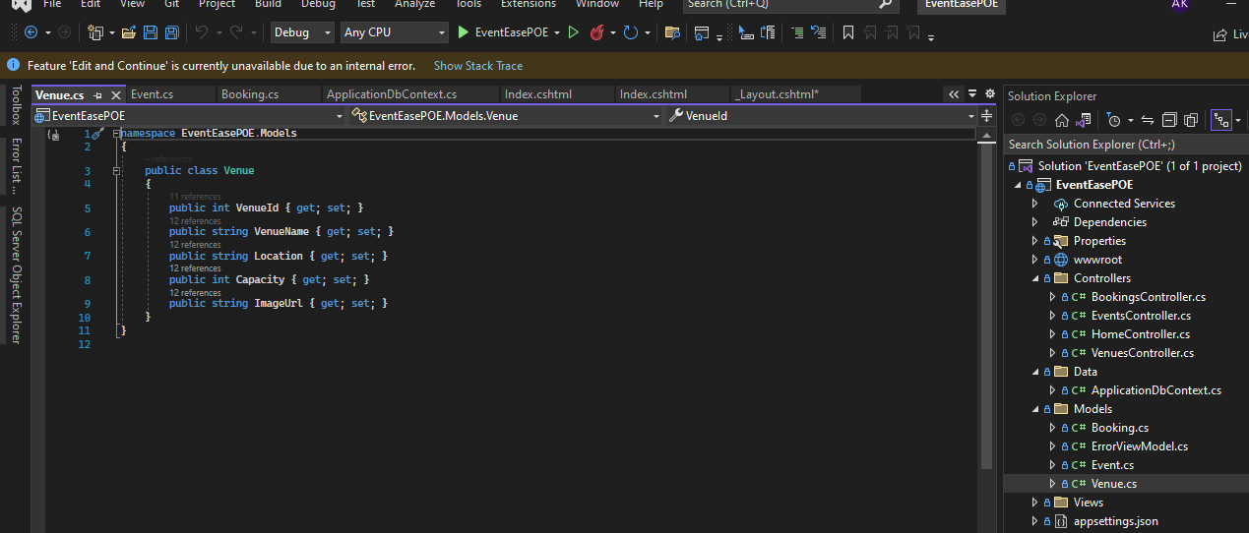

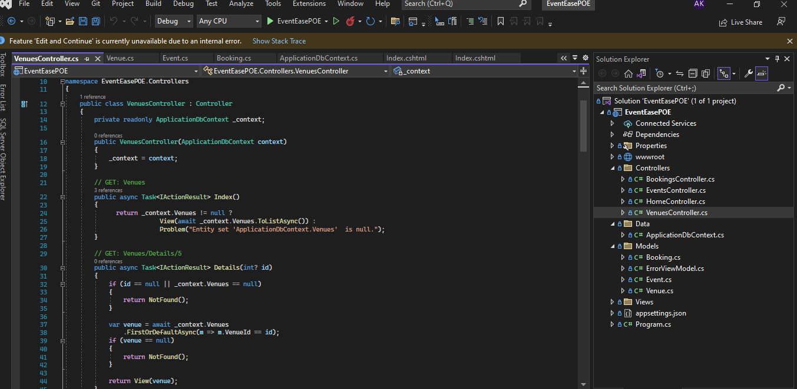

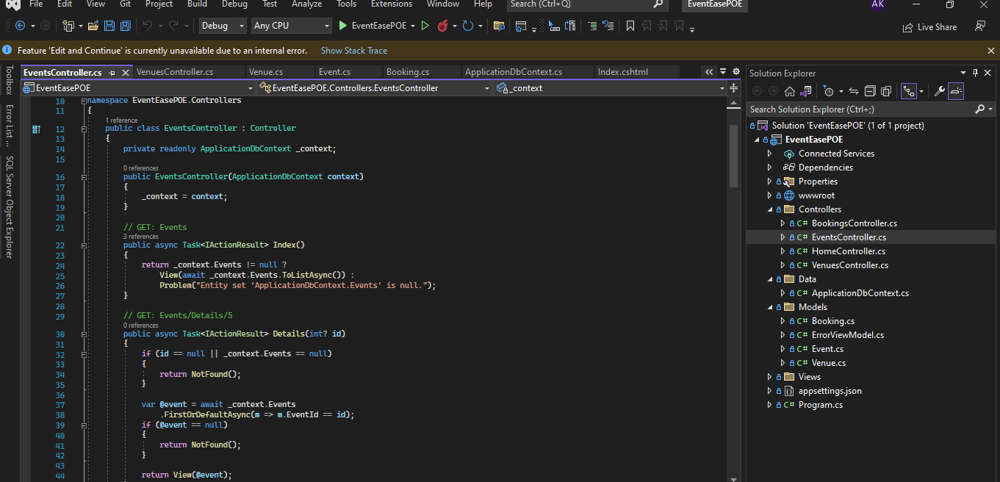

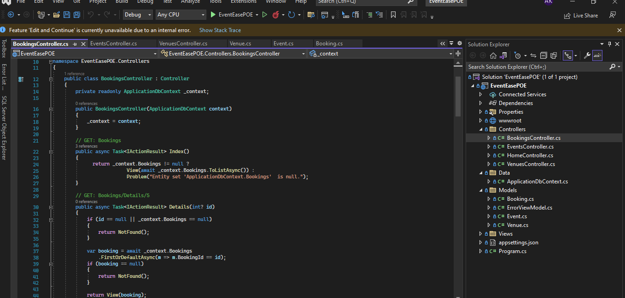

Screenshots of ssms

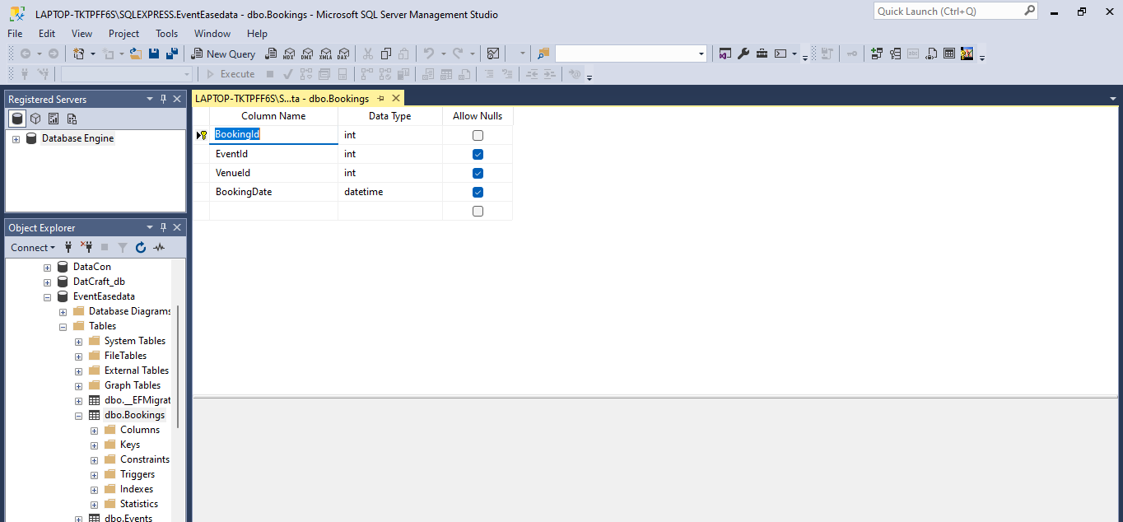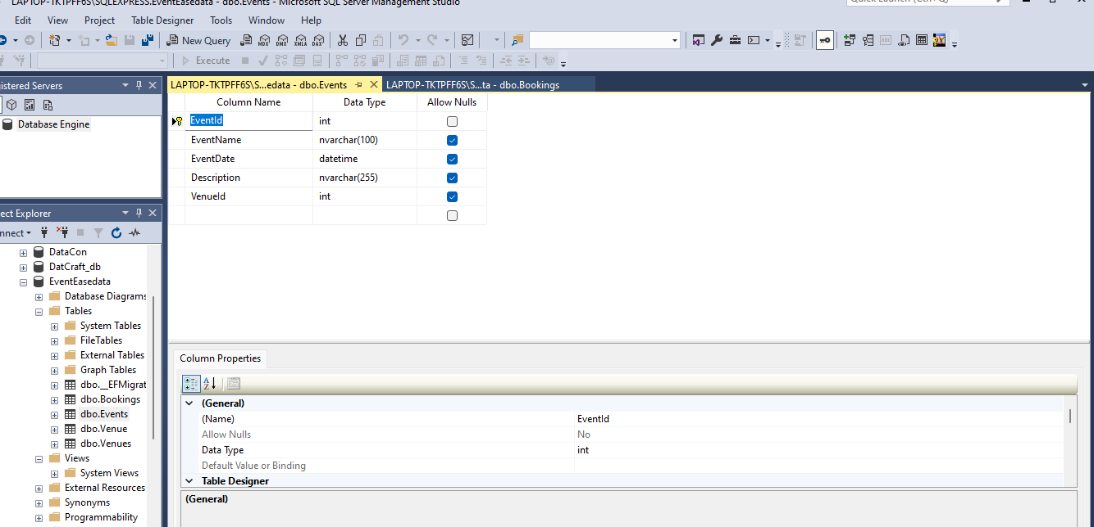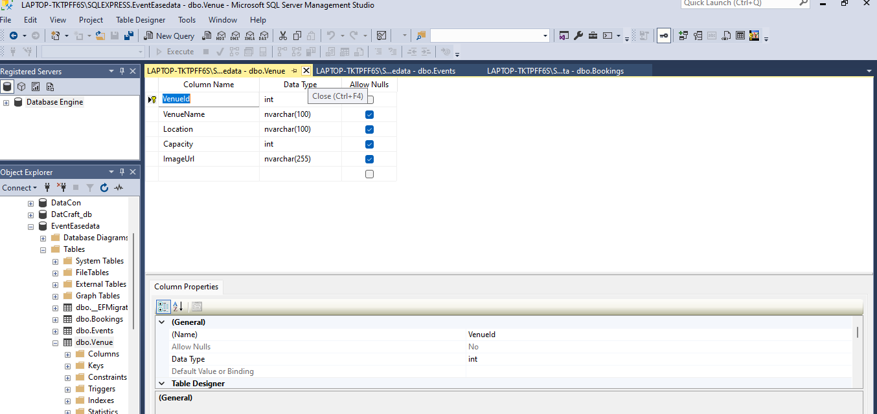

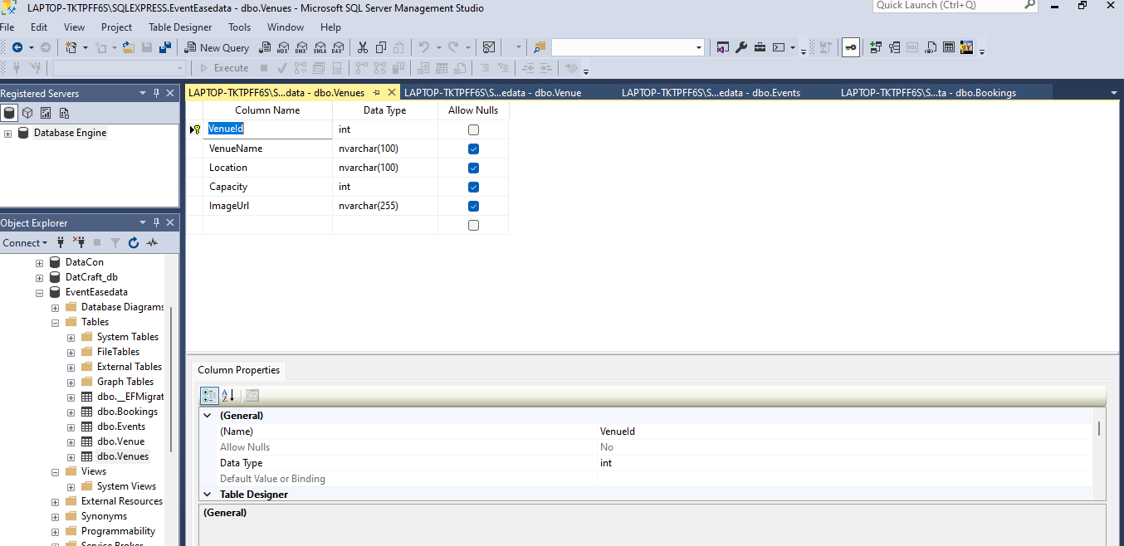

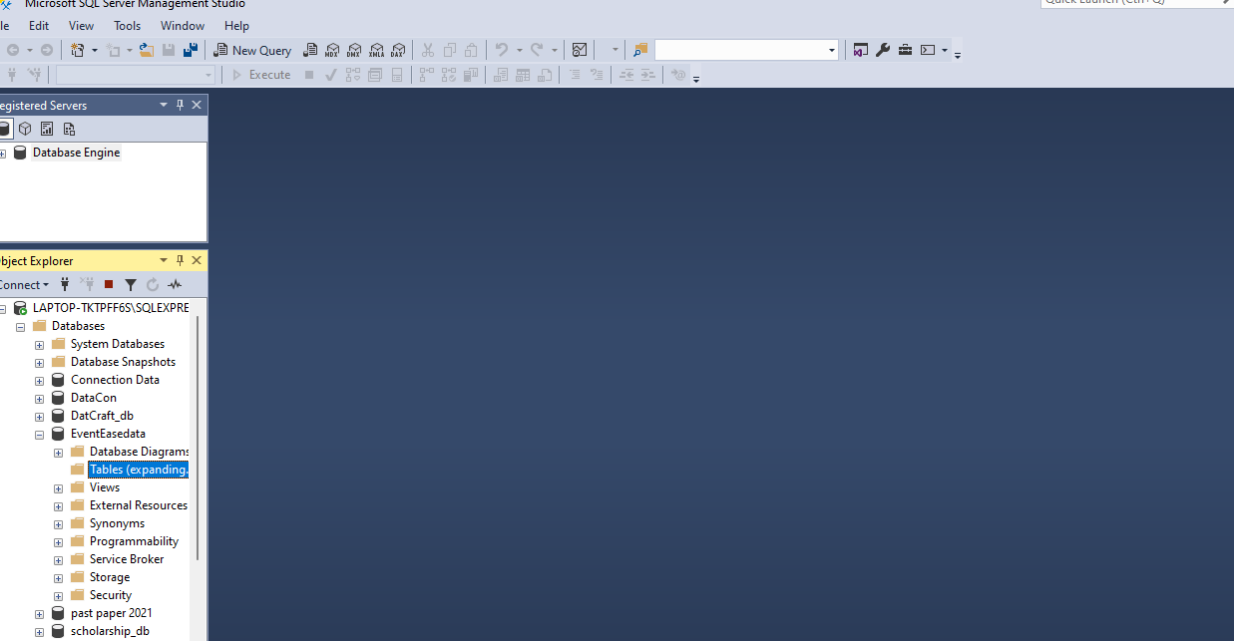

Screenshots of deployment

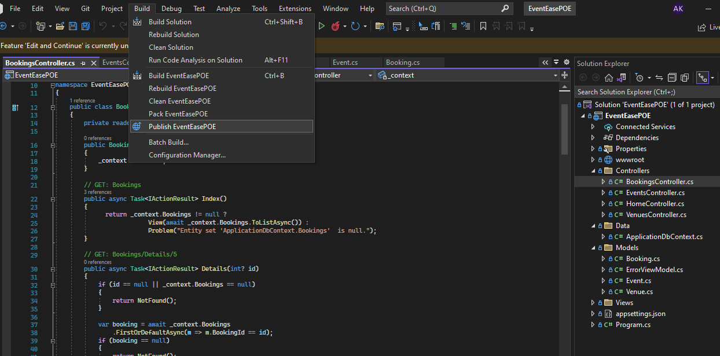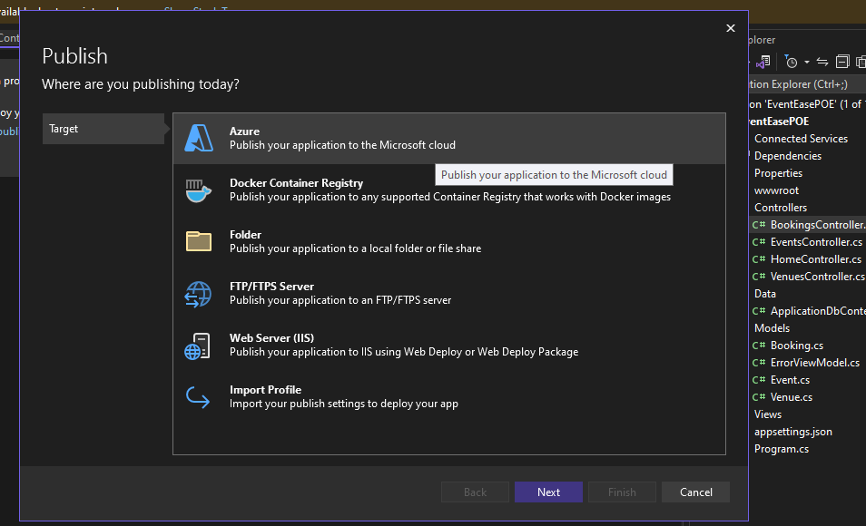

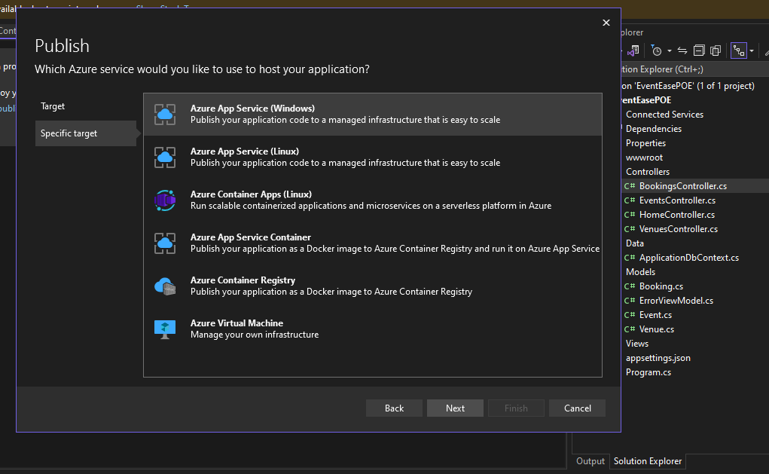

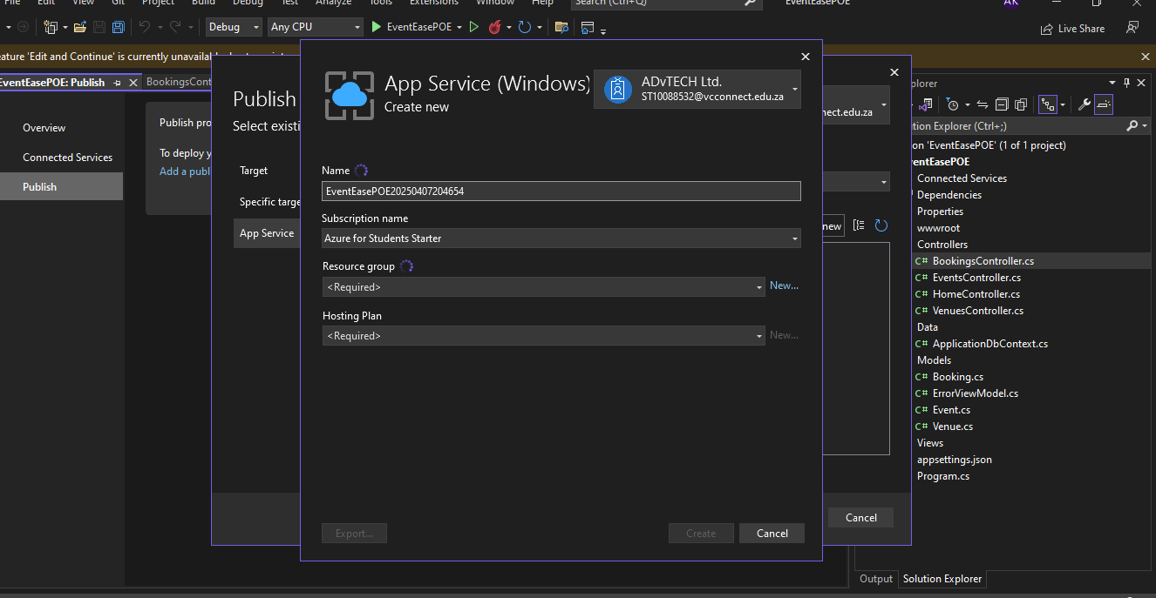

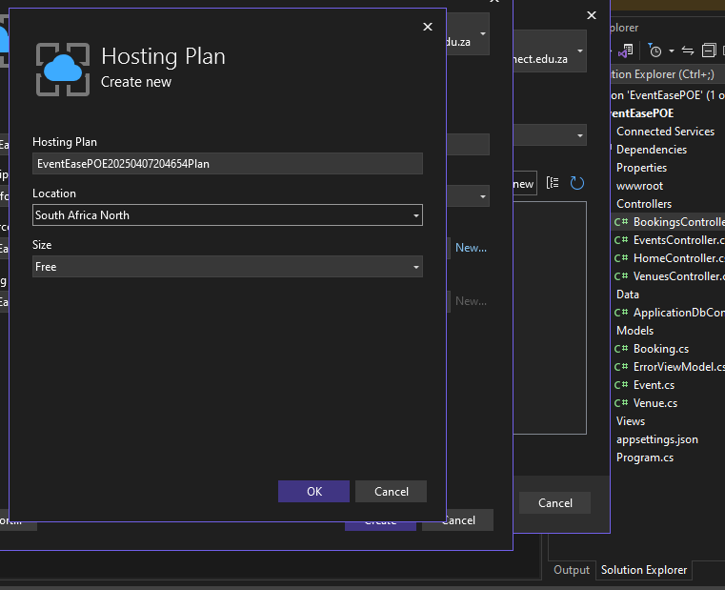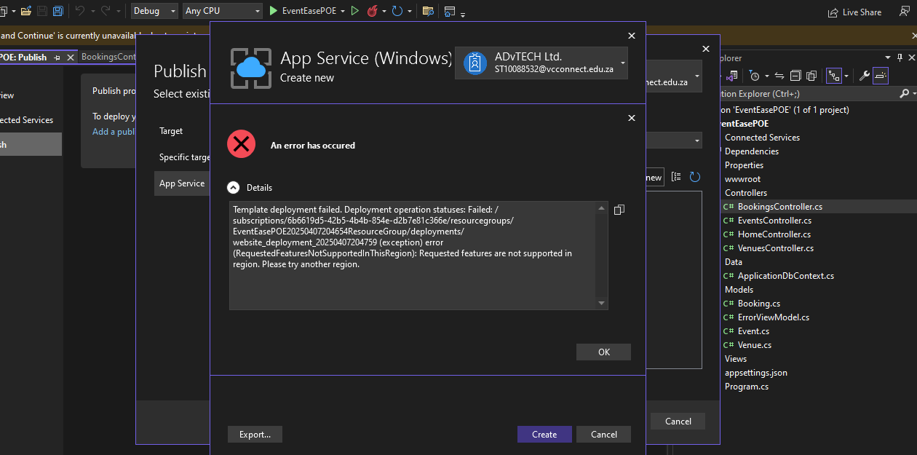

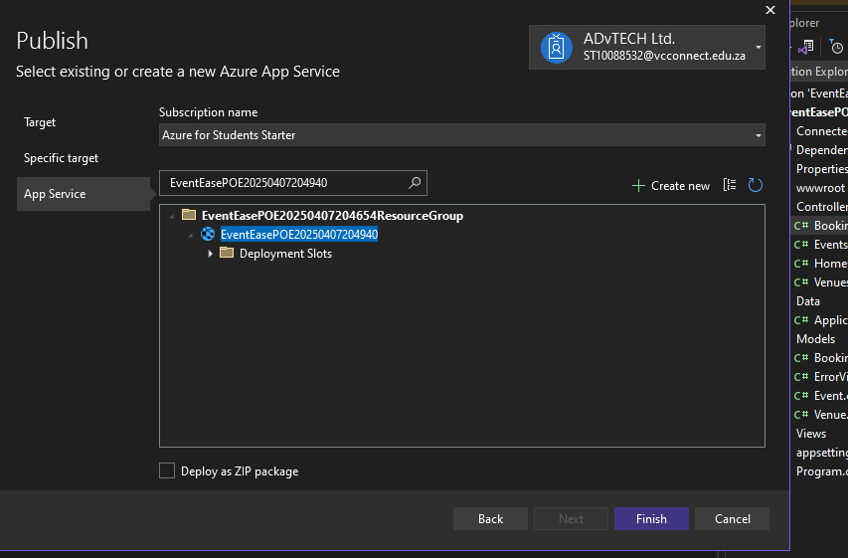

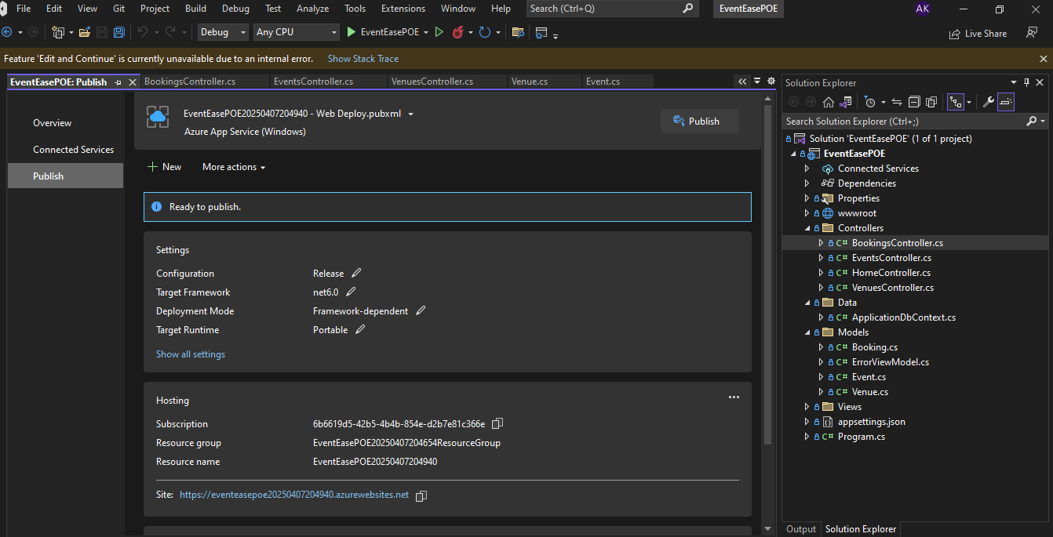

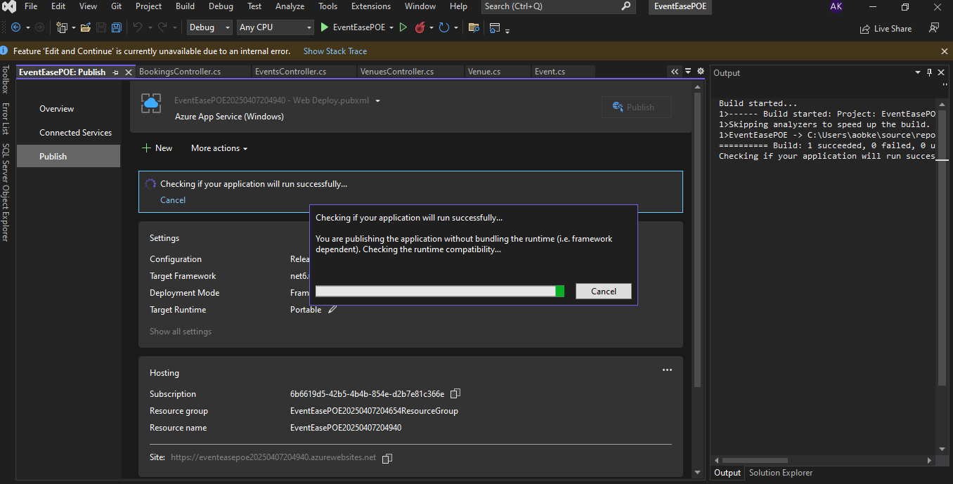

GIThub repository link

https://github.com/ST10088532/VCSANDTON-CLDV6211-ST10088532.git

Web app url

<https://eventeasepoe20250407204940.azurewebsites.net>

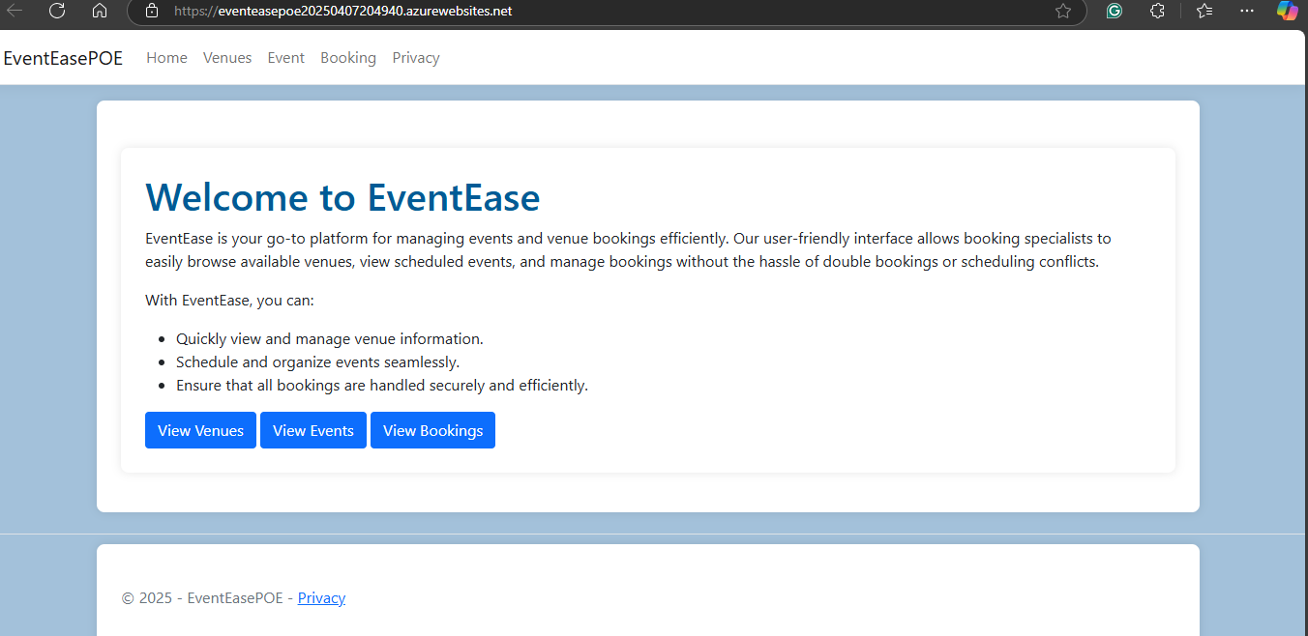

Part D

1. On-premise software is installed on a company's network/infrastructure. Cloud software relies on a provider’s servers and is accessed using the web. While cloud computing offers flexibility and cost-efficiency, on-premise options offer dependability, security, and control. Mostly a blend of on-premise, cloud and SaaS applications is necessary for continued business growth.

Example, If EventEase decided to deploy on-premises they would need to hire cybersecurity employees/workers to setup firewalls, check the network and system for any threats and make sure the physical server secure.

1. IaaS is an on-demand access to cloud-hosted physical and virtual servers, storage and networking—the backend IT infrastructure for running applications and workloads in the cloud. PaaS is on-demand access to a complete, ready-to-use, cloud-hosted platform for developing, running, maintaining and managing applications.  
   SaaS, or software as a service, is on-demand access to ready-to-use cloud-hosted application software. (Mrzyglod, 2022) (Ron Karjian, 2024) (S., n.d.)

Example EventEase use Iaas so they need to configure virtual machines, install web servers and manage Operating system patches/updates. With Saas they would have to adapt their business processes to fit available software. With Paas comes the perfect balance by using Azure App Service and Azure SQL Database, EventEase can deploy their event booking app, while maintaining control over their application's functionality and user experience. (Mrzyglod, 2022) (Ron Karjian, 2024) (S., n.d.)

Part 2

Azure database creation:

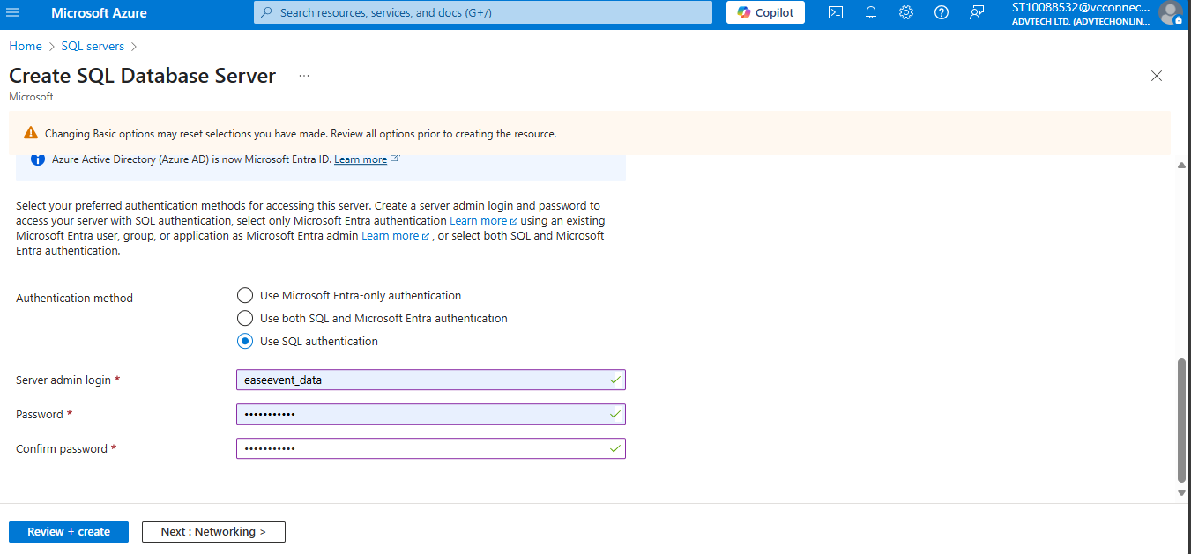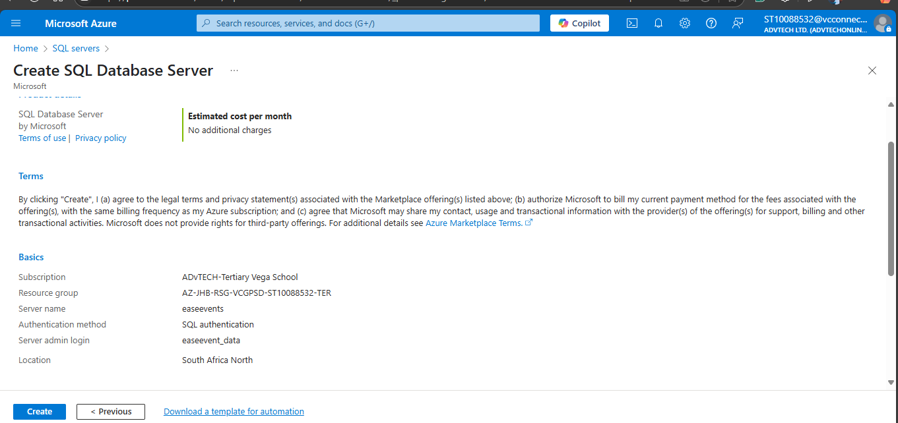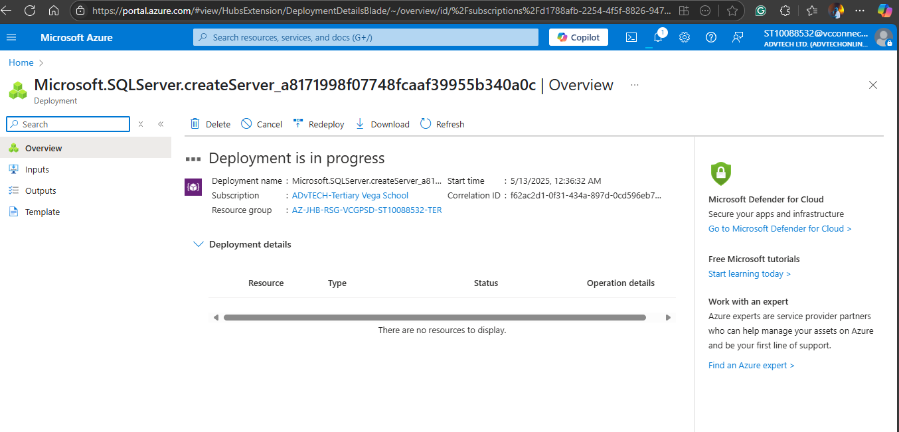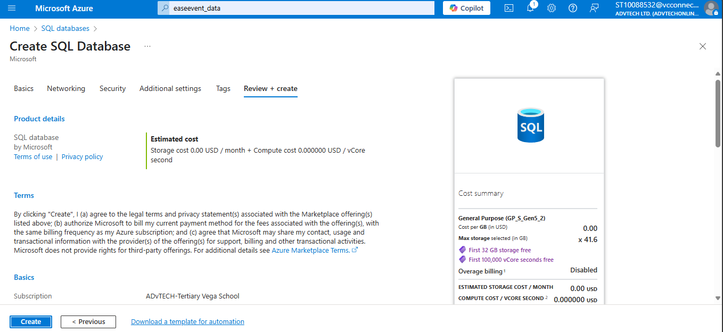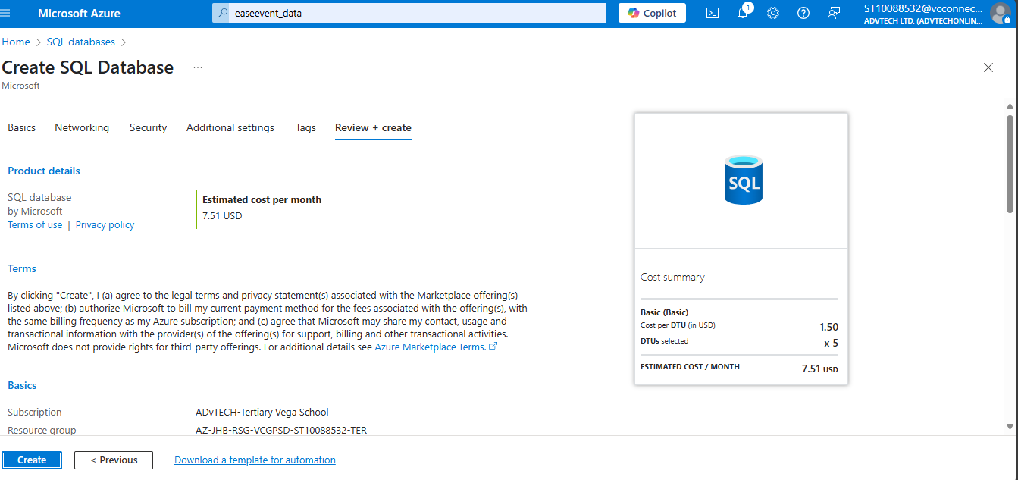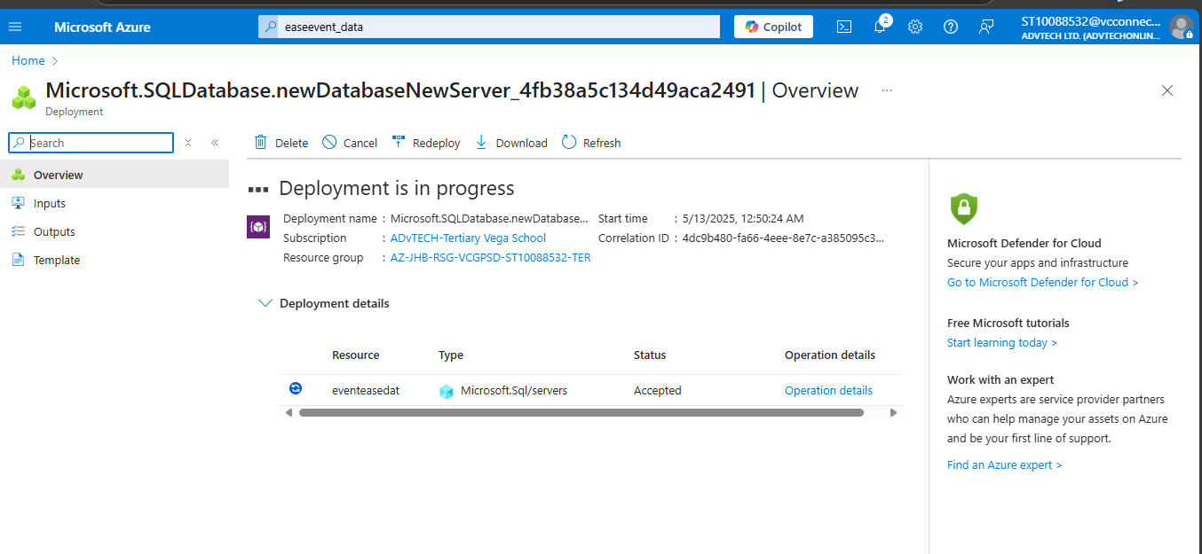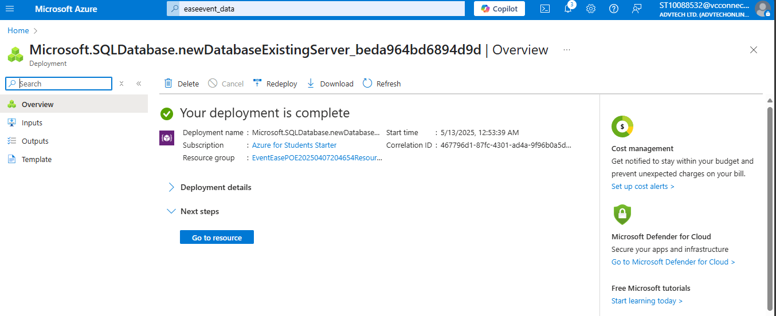

Code Corrections:

Updated json file with azure connection string.

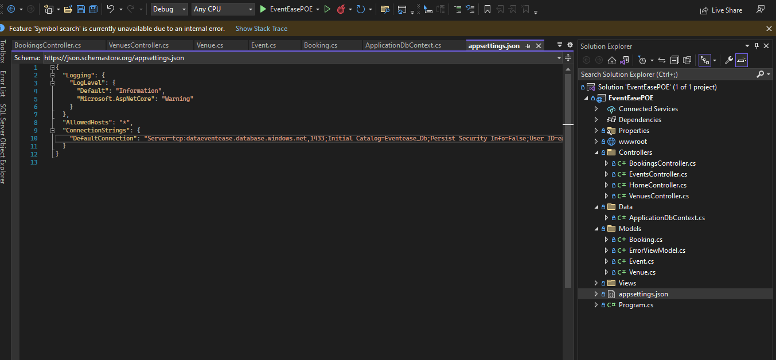

Updated connection to azure:

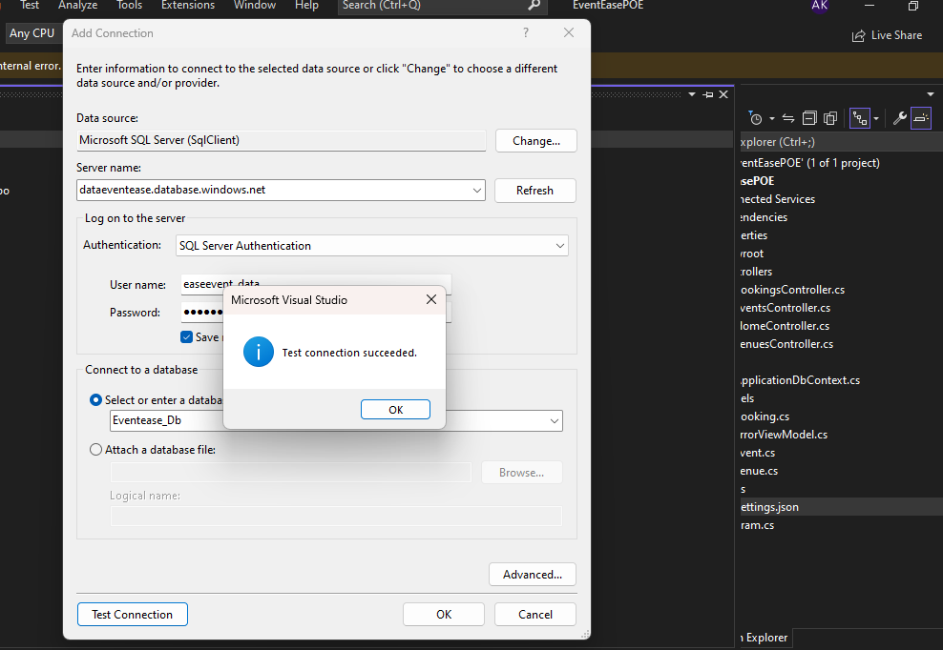

Adding Migrations and Updating Database:

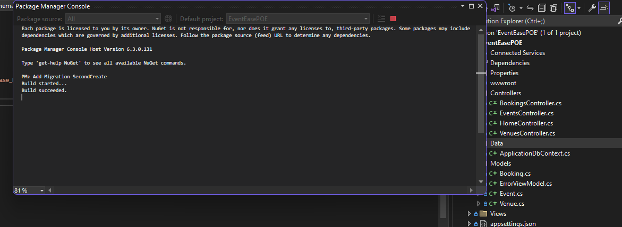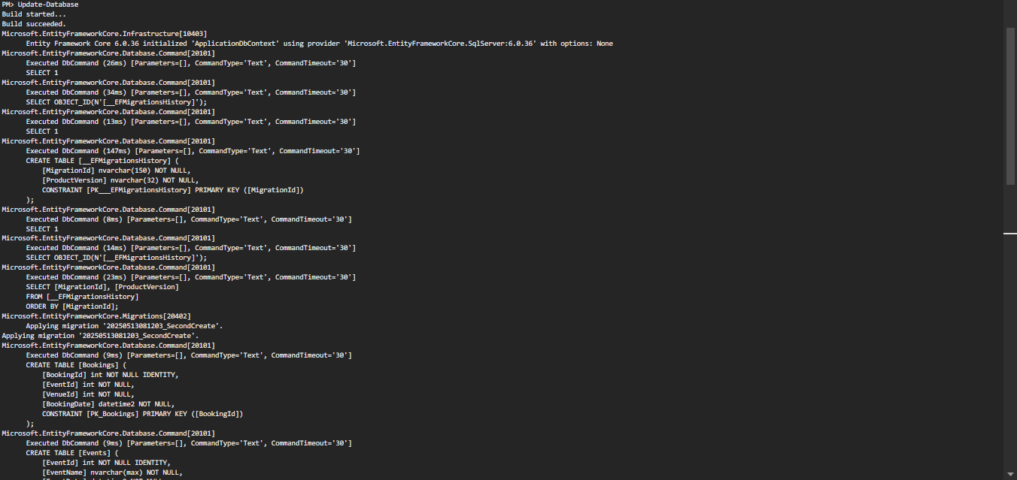

1. Creating Azure Storage Account

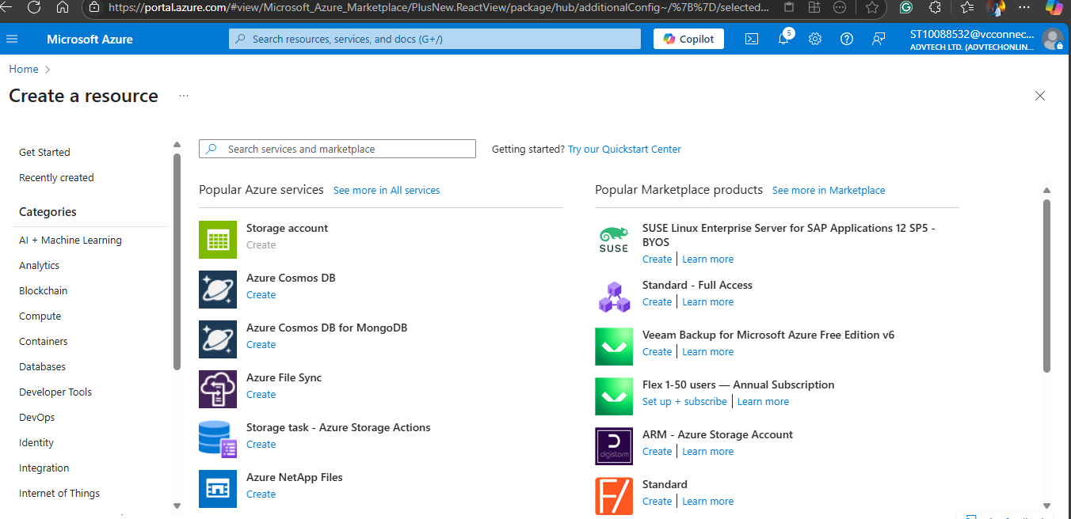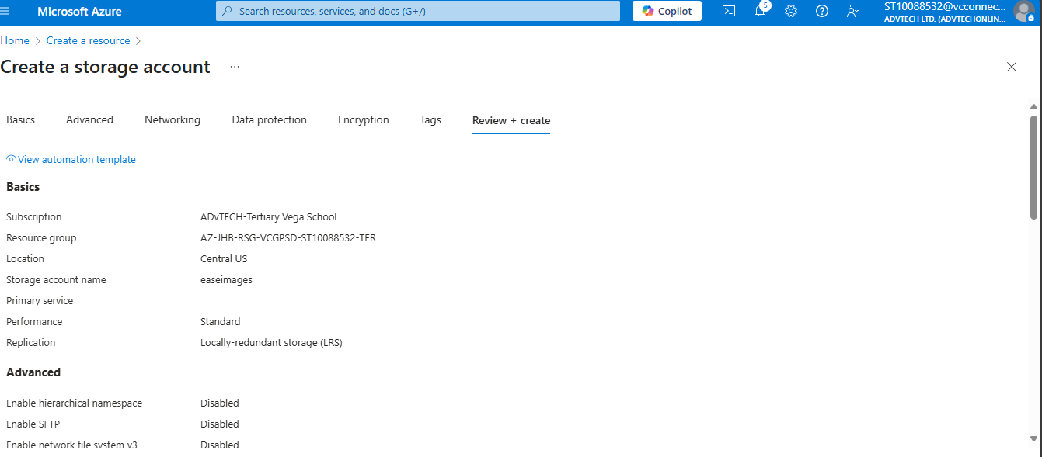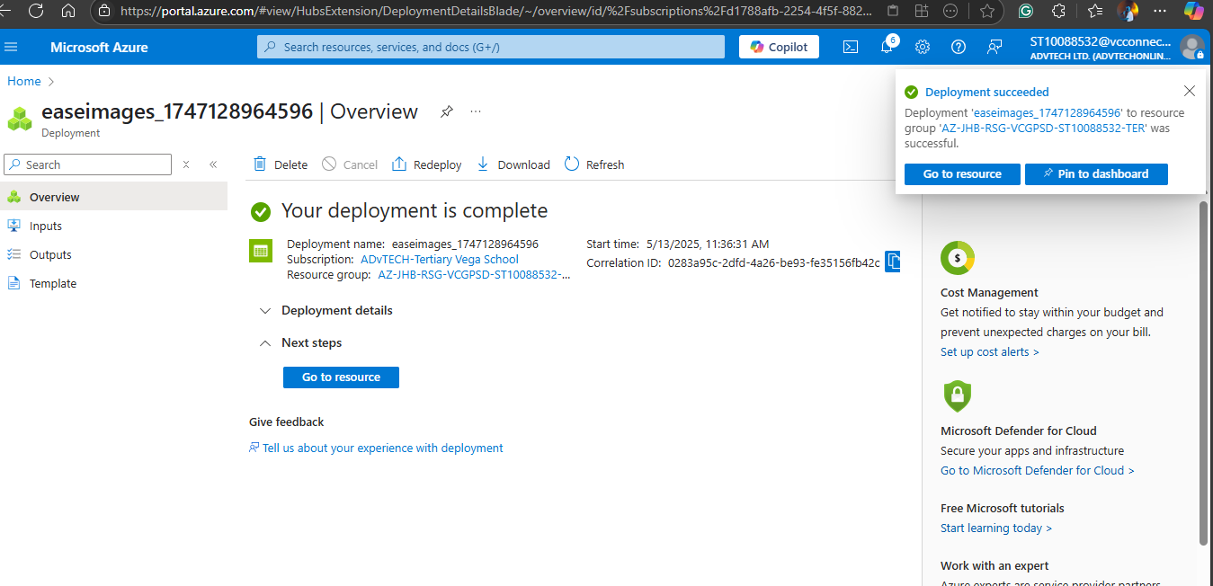

Integration of Azure Storage:

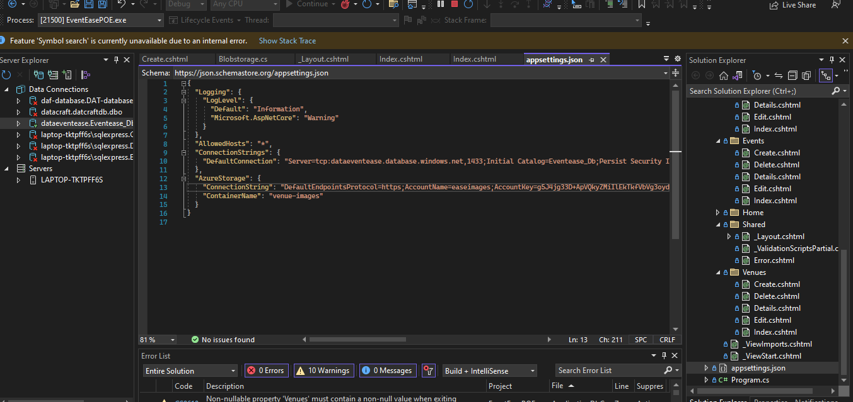

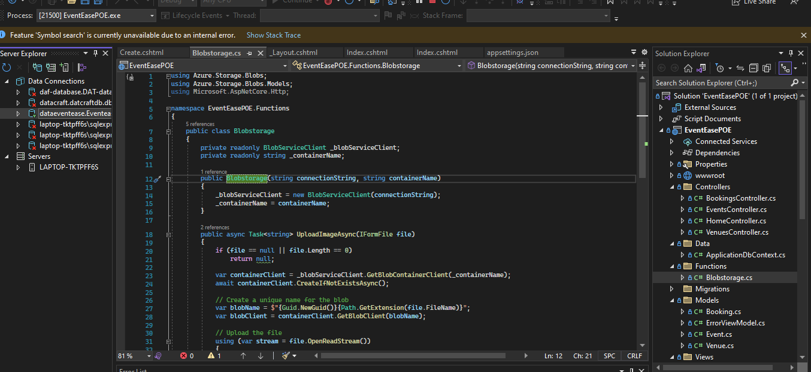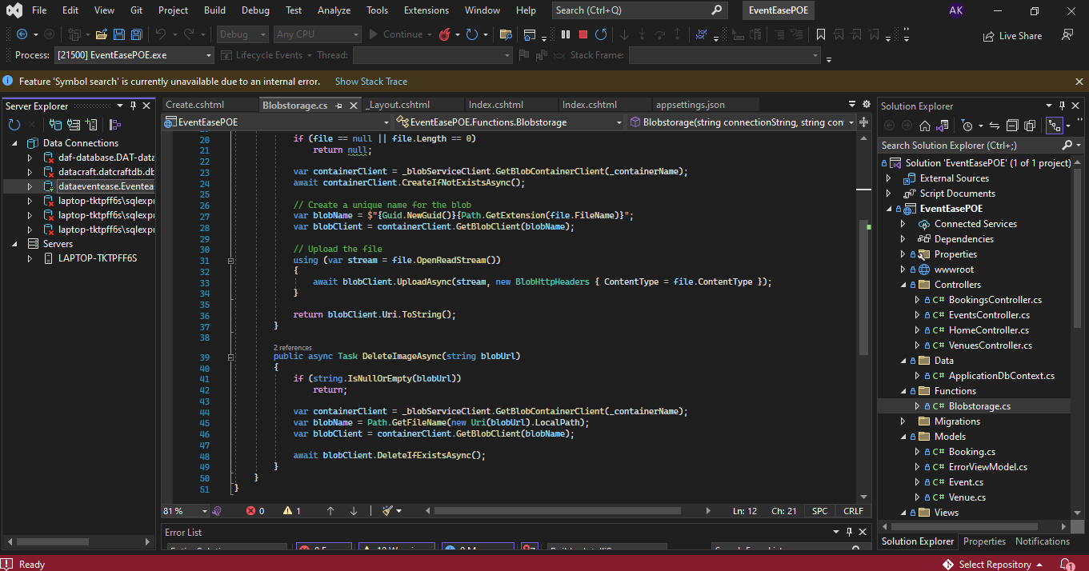

1. Implementing error handling and validations

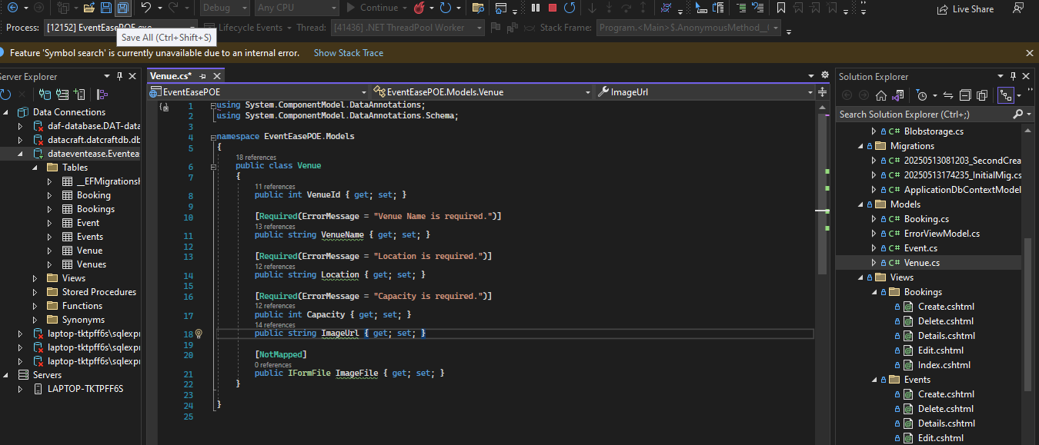

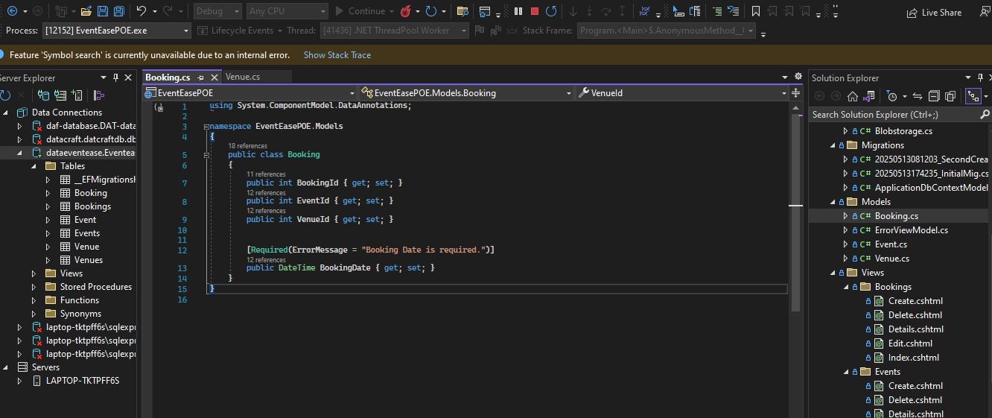

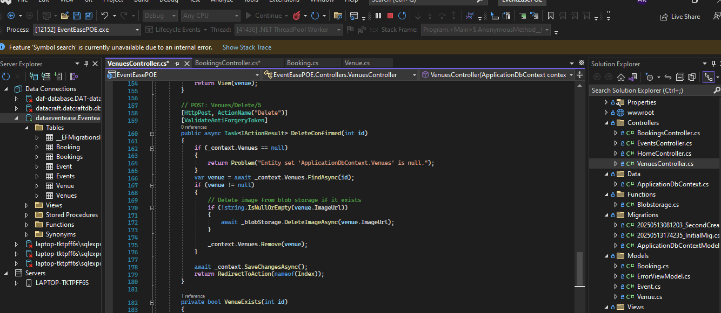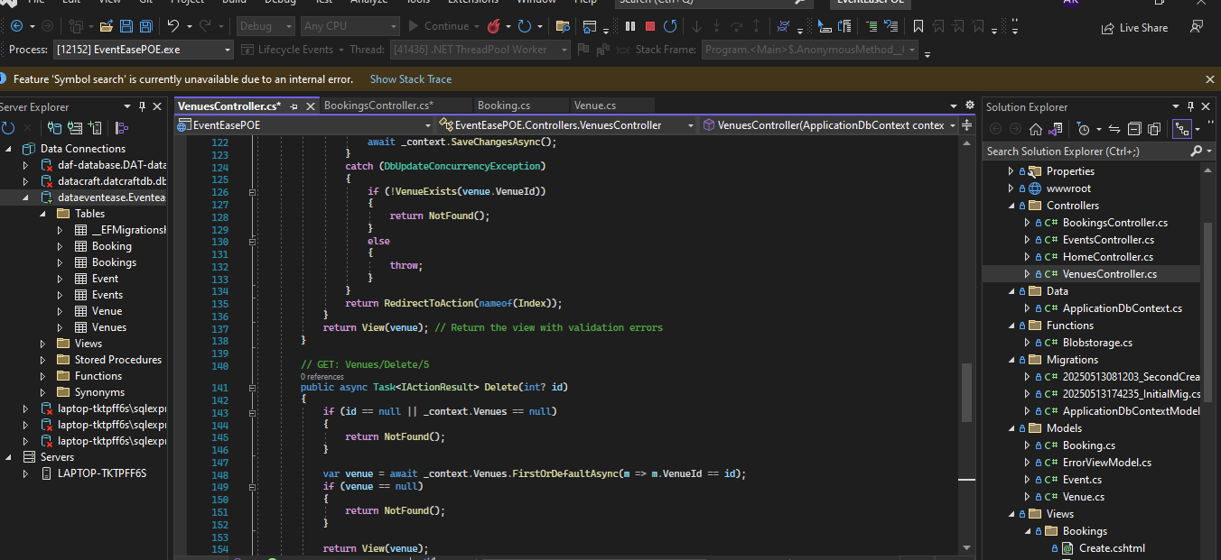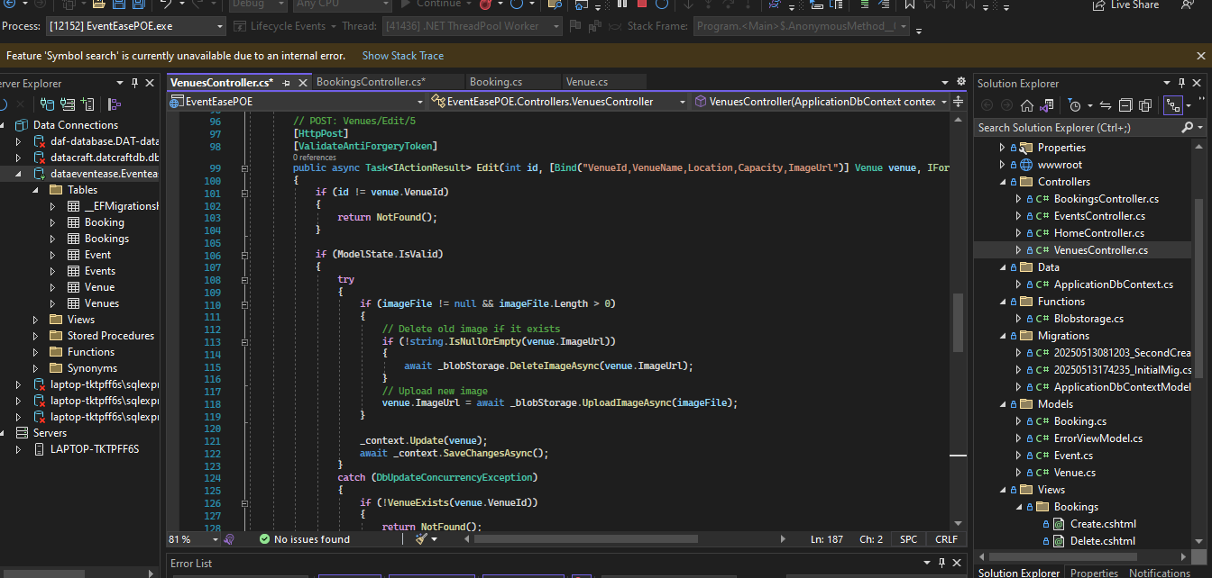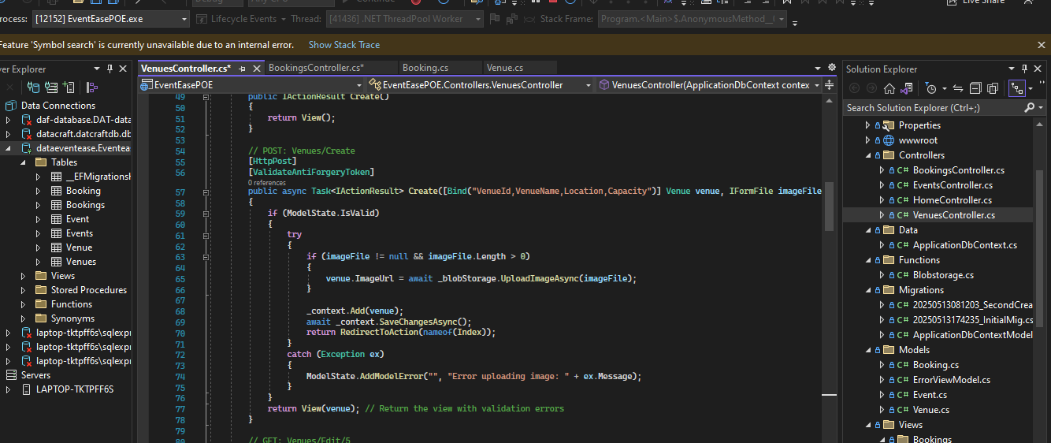

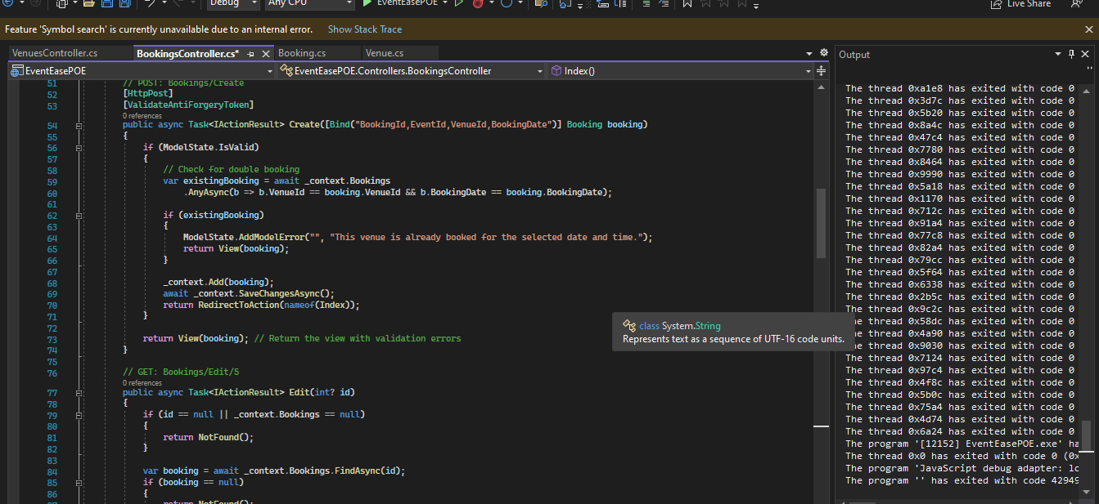

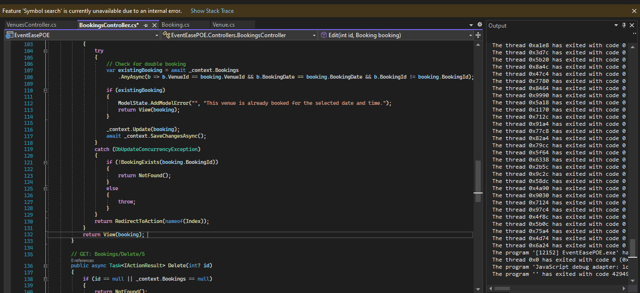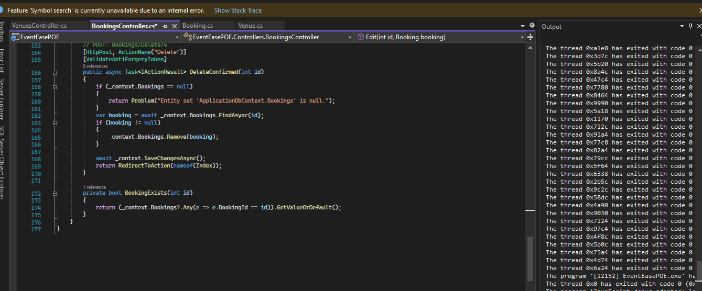

1. Enhanced Display and Search:

Booking view class:

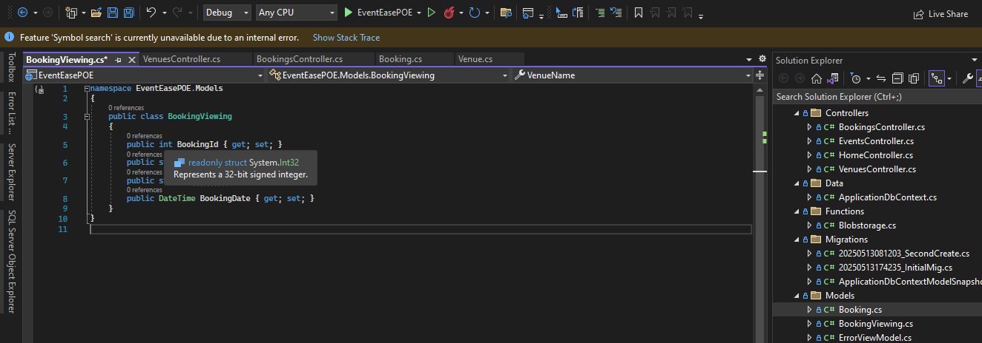

Improved index class/cshtml:

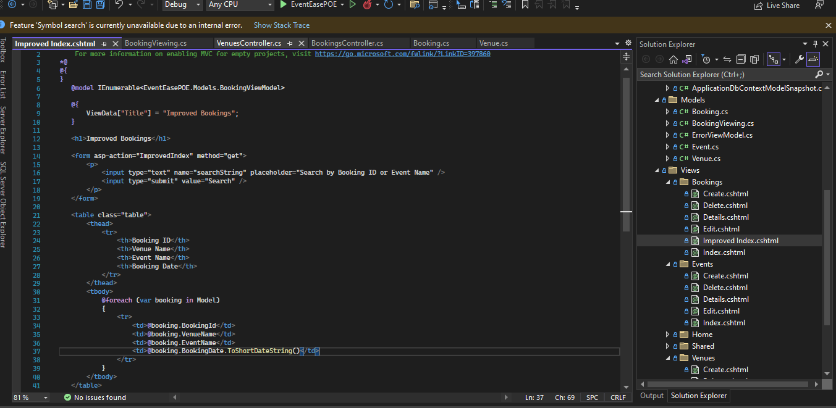

Improved index added to bookings controller:

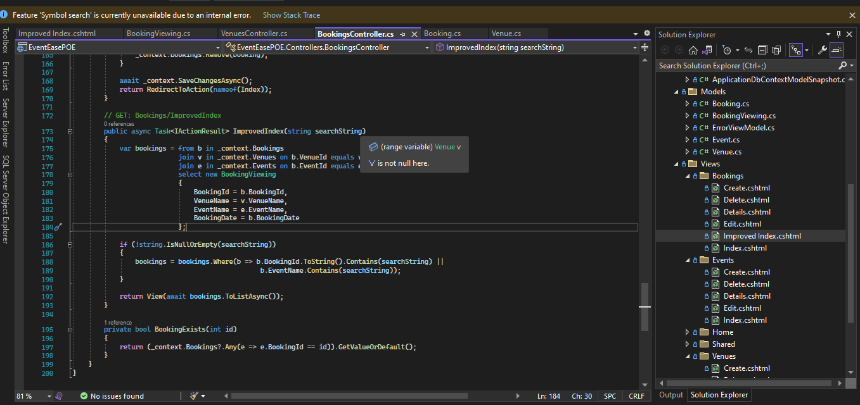

(BillWagner, 2024)

Database Update:

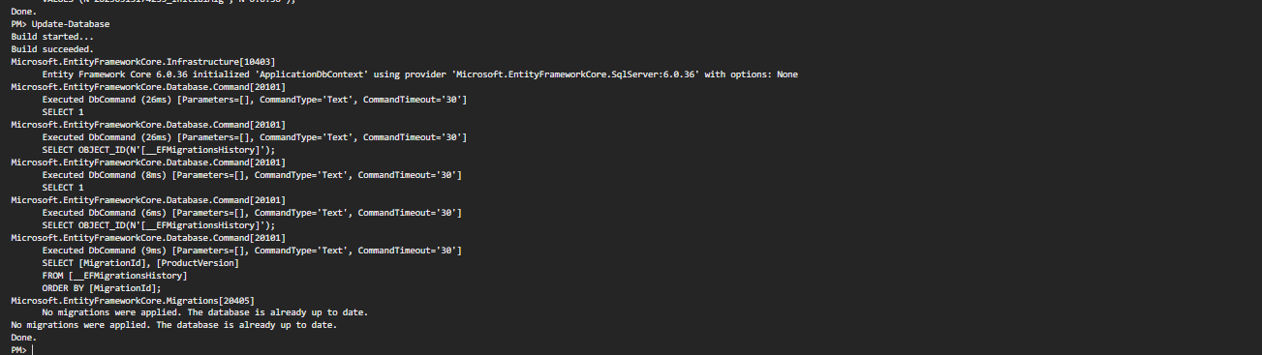

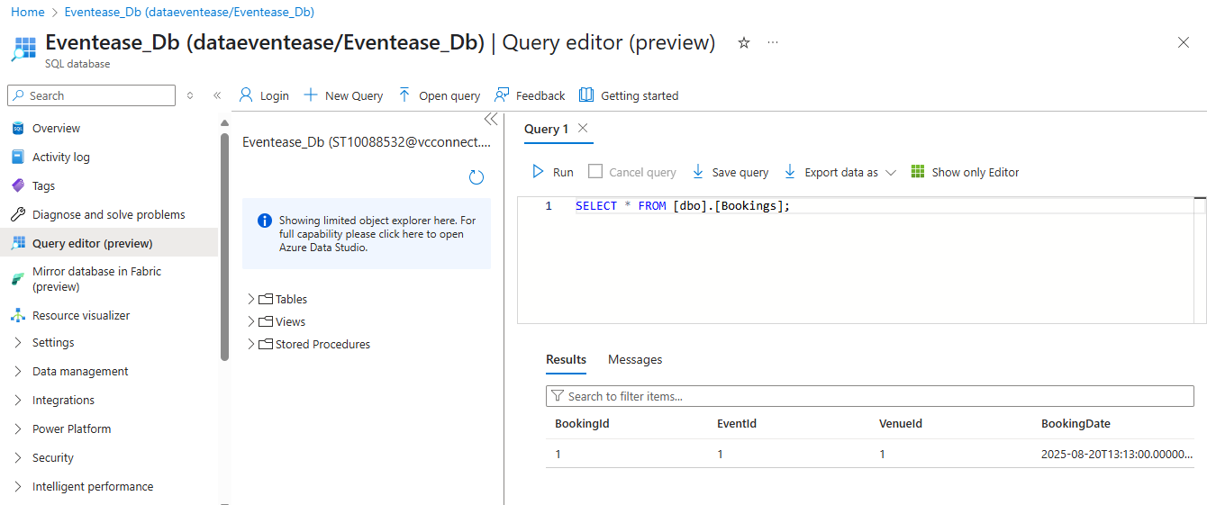

1. Azure deployment Updates:

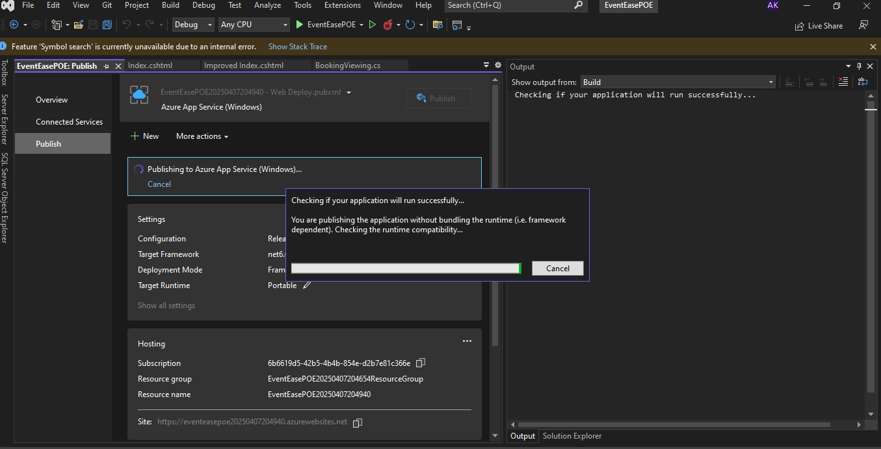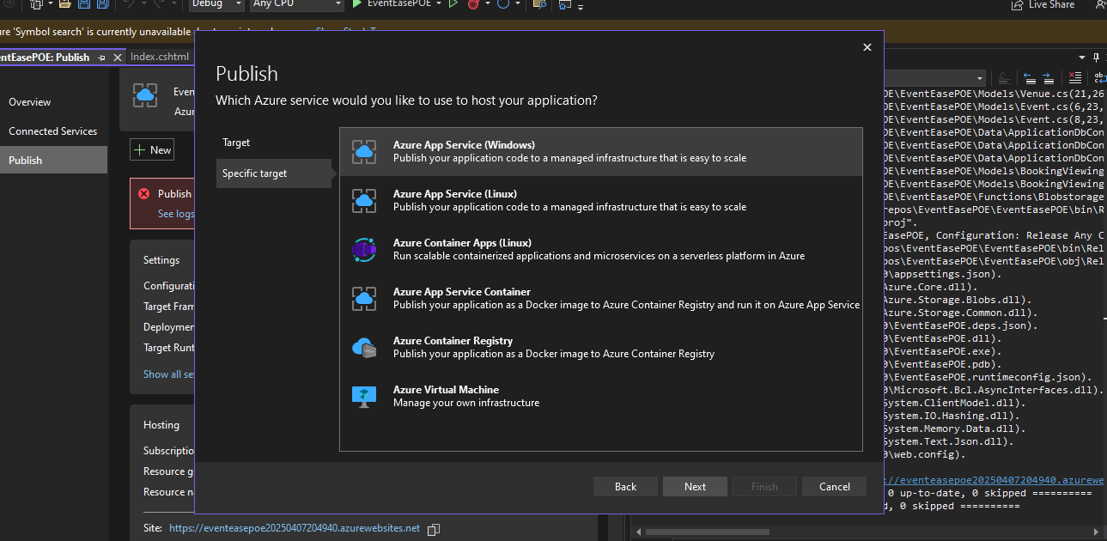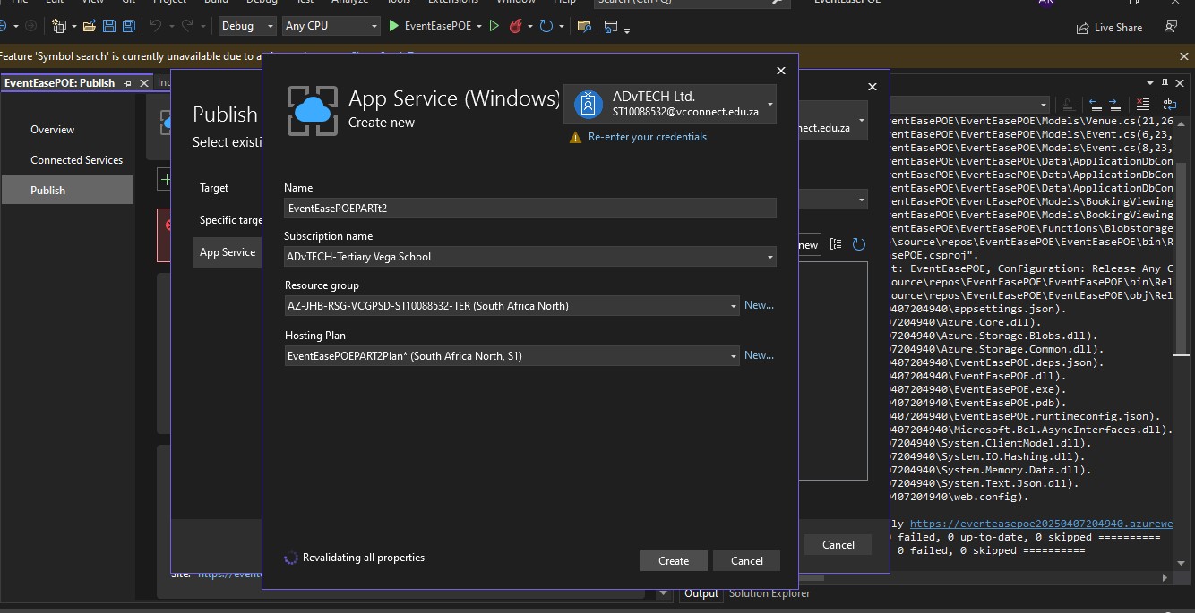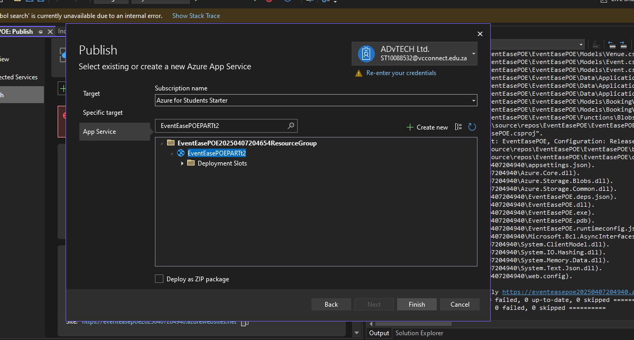

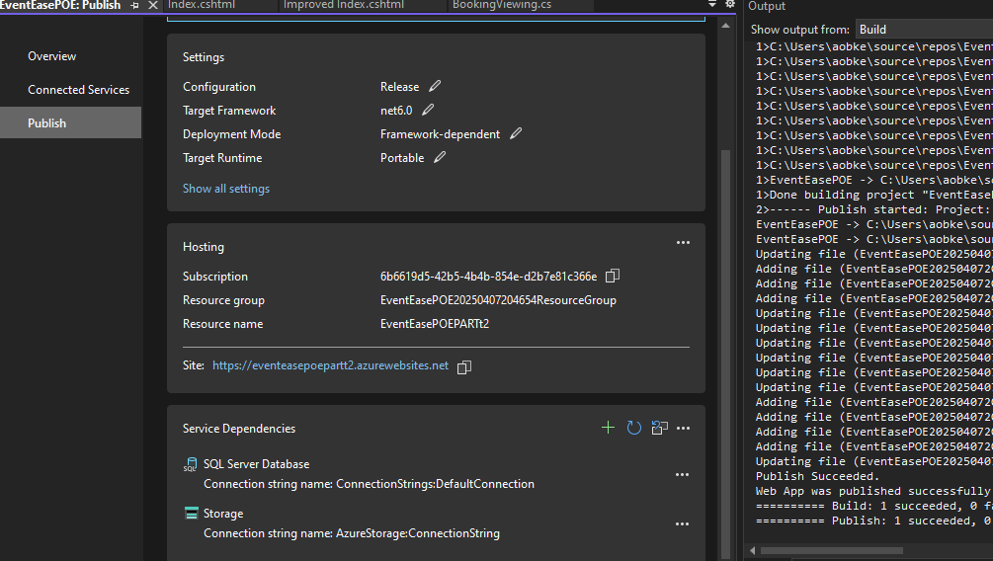

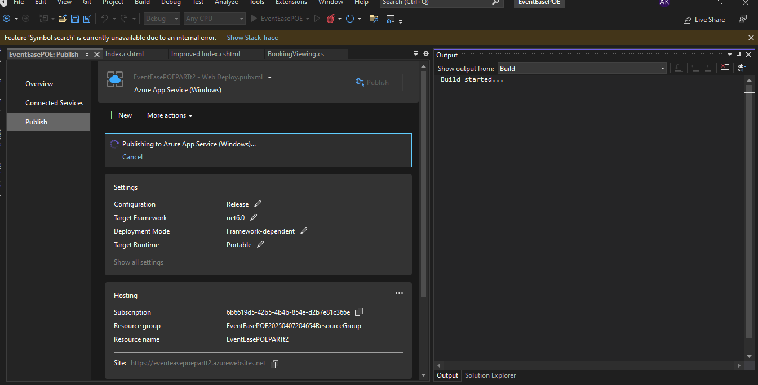

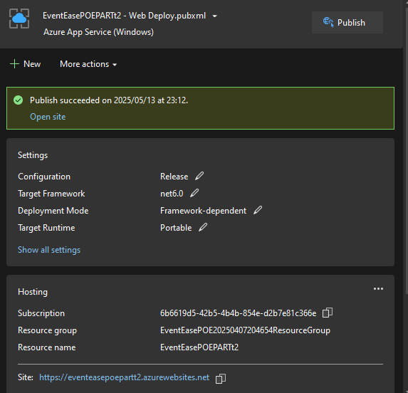

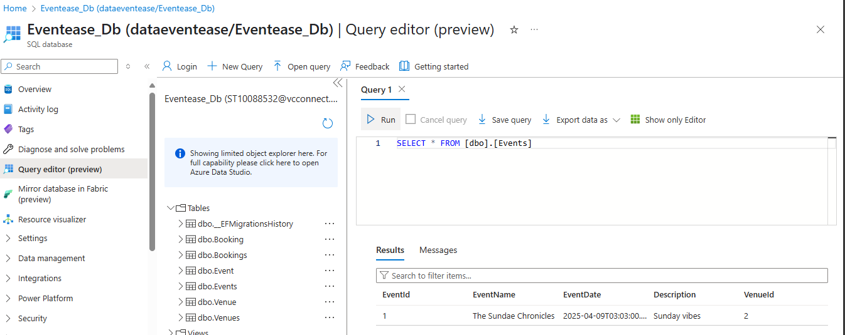

E. Database Design, Cognitive search

1. Azure cognitive search is a cloud-based search service from Microsoft that helps developers build and manage powerful search experiences. It allows users to index and query content from various sources, including websites, databases, and documents. (HeidiSteen, 2025) (Brush, 2023) Traditional search engines, like Google, Bing, and Yahoo, rely on indexing and ranking algorithms to deliver search results. They crawl the web, index content, and then use algorithms to match user queries with relevant information. These engines excel at finding specific web pages or documents based on keyword matching and offer features like advanced query syntax and filters. (Kerner, 2024) The system strongly excels in understanding the sophisticated queries, contextually recommending, and ranking results based on true relevance against the actual query instead of inflating counts of keyword matches.

2. “This process makes your database simpler to navigate while also enhancing the precision and integrity of your data. Data normalization ensures that all of the records in the database of customers have the same appearance, readability, and usability.” By reducing data redundancy, minimizing cloud storage costs and improving elastic scaling capabilities.

The impact on normalised structures, it is organizing your data so you don't repeat the same information everywhere. Instead of having customer names in every order record, you store them once and reference them. It is important because normalized data is much easier to manage across multiple servers when it comes to scaling issues and It keeps cloud data consistent.

The impact on denormalised structures, Combining of data from multiple different tables is done for optimizing data retrieval into one single table or document. It reads faster because joining is less necessary.

Data that is readily available in just a single table simplifies any queries.

Updates become more complex with potentially wasting storage space also data redundancy increases. It can compromise data, if one does not manage it carefully. Data's careful management is important for its integrity. (Kordos, 2024)

URL Links:

GITHUB: https://github.com/ST10088532/VCSANDTON-CLDV6211-POE-PART2.git

Azure published link: https://eventeasepoepartt2.azurewebsites.net

# Bibliography

BillWagner, 2024. *Resolve errors and warnings related to assembly references.* [Online]   
Available at: https://learn.microsoft.com/en-us/dotnet/csharp/language-reference/compiler-messages/assembly-references?f1url=%3FappId%3Droslyn%26k%3Dk(CS0234)  
[Accessed 10 May 2025].

Brush, K., 2023. *cognitive search.* [Online]   
Available at: https://www.techtarget.com/searchenterpriseai/definition/cognitive-search  
[Accessed 10 May 2025].

HeidiSteen, e.-u. s.-a., 2025. *What's Azure AI Search?.* [Online]   
Available at: https://learn.microsoft.com/en-us/azure/search/search-what-is-azure-search  
[Accessed 10 May 2025].

Kerner, S. M., 2024. *https://www.techtarget.com/whatis/feature/GenAI-search-vs-traditional-search-engines-How-they-differ#:~:text=Traditional%20search%20engines%20help%20users,and%20brief%20description%20or%20snippet..* [Online]   
Available at: https://www.techtarget.com/whatis/feature/GenAI-search-vs-traditional-search-engines-How-they-differ#:~:text=Traditional%20search%20engines%20help%20users,and%20brief%20description%20or%20snippet.  
[Accessed 10 May 2025].

Kordos, A., 2024. *Normalization vs. Denormalization in databases.* [Online]   
Available at: https://codilime.com/blog/normalization-vs-denormalization-in-databases/  
[Accessed 10 May 2025].

Mrzyglod, K., 2022. *Azure for developers , Implement rich Azure Paas Ecosytems using containers, serverless services, and storage solutions.* 2nd ed. Birmingham: Packt Publishing Ltd..

Ron Karjian, Z. F., 2024. *On premises vs. cloud pros and cons, key differences.* [Online]   
Available at: https://www.techtarget.com/searchcloudcomputing/tip/Evaluate-on-premises-vs-cloud-computing-pros-and-cons  
[Accessed 01 April 2025].

S., N., n.d. *On-Premises vs Cloud: Key Differences, Pros & Cons.* [Online]   
Available at: https://www.cloudpanel.io/blog/on-premises-vs-cloud-computing/  
[Accessed 01 April 2025].